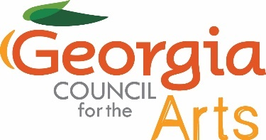

**Georgia Council for the Arts**

**July 23, 2025**

**Agenda**

1:00 Call to Order Colt Chambers

Approve Minutes Colt Chambers

1:05 Grants Update Allen Bell

1:20 NEA Update Tina Lilly

1:30 Governor’s Awards Update Tina Lilly

1:40 Traveling Exhibit Update Kenny Oaster

1:50 Legislative Visits Tina Lilly

2:25 Council Communication and Involvement Colt Chambers

2:45 Break

3:00 Tour of the State Art Collection Kenny Oaster

3:30 Adjourn