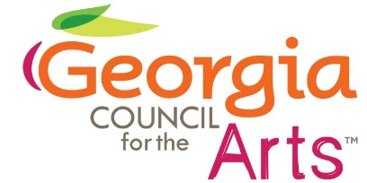

**Georgia Council for the Arts**

**Council Meeting**

**April 8, 2025**

1:00 Welcome Colt Chambers

Update on GCA Arts Fund

1:10 Update on the NEA and Executive Orders Tina Lilly

1:20 FY25 Grants Allen Bell

1:30 Traveling Exhibit Kenny Oaster

State Art Collection

1:50 Governor’s Awards Tina Lilly

2:05 Council Support for GCA Colt Chambers

2:30 Break

2:45 Tour of Otis Redding Foundation Karla Redding Andrews

3:30 Walk to Macon Arts Julie Wilkerson

Presentation on Macon Arts

4:00 Adjourn