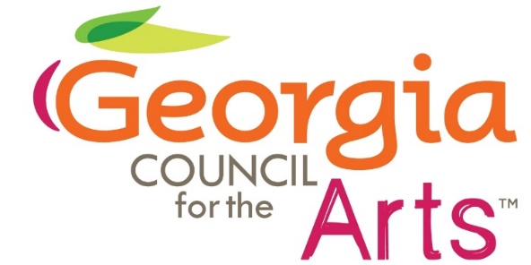

Council Meeting

January 23, 2025

1:05pm-2:23pm

Via Online

**In Attendance**

Council Members: Colt Chambers, Gina Jeffords, Linda

Nicholson, Karla Redding-Andrews, Brandy Baker, Michele Arwood, Joanne Chesler Gross

**GCA Staff**

Allen Bell, Tina Lilly, Delilah Johnson, Emily Yewell Volin, Tyrone Webb, Olivia Byers, Kenny Oaster

**GDECD Staff**

Sara Gershon

Meeting called to order by Chair Colt Chambers at 1:05 pm

**Motion to approve the minutes from the previous meeting made by Michele Arwood, second by Karla Redding-Andrews. Minutes approved.**

**1:05pm**

GCA Executive Director Tina Lilly

Governor Awards Discussion

**1:14pm**

Chair Colt Chambers

Arts Foundation Discussion

**1:48pm**

Visual Arts Manager Kenny Oaster

Reimagine Traveling Exhibit Updates

**2:03pm**

Grants and Arts Education Program Manager Emily Yewell Volin

Poetry Out Loud Updates

**2:12pm**

Director of Grants and Research Allen Bell

FY25 Grant Data Updates

Motion to adjourn made by Karla Redding-Andrews, second by Michele Arwood. All in favor