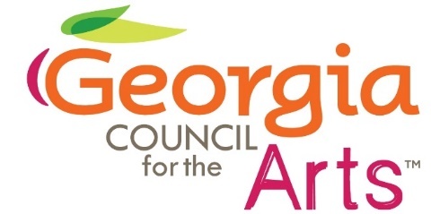

Council Meeting
February 21, 2024
Virtual Meeting via Teams

In Attendance
Council Members: Colt Chambers, Gladys Wyant, Bryan Brooks, Joanne Chesler, John White, Gina Jeffords, Maxine Burton, Linda Nicholson
Staff: Allen Bell, Tina Lilly, Delilah Johnson, Emily Yewell Volin, Tyrone Webb

Meeting called to order by Chair Gladys Wyant at 2:02 pm

Motion to approve the minutes from the previous meeting made by Colt Chambers, second by John White. Minutes approved

Grants Update
- Allen Bell, Director of Grants and Research, gave an update on the FY25 number of grants applications that have been submitted for Bridge and Project Grants.
- Tyrone Webb, Rural and Community Arts Manager, presented brief summaries of the types of projects that were funded by FY24 Project and Vibrant Community Grants.

Grant Panel Introduction
Allen Bell provided a summary of the duties of FY25 grant panelists.

Arts Education Update
Emily Yewell Volin, Arts Education Program Manager, provided an update on the Teaching Artist Registry, Poetry Out Loud, Poet Laureate Prize, and the FY25 Arts Education Grant.

Economic Impact Study
Executive Director Tina Lilly presented the highlights of the Americans for the Arts’ Arts and Economic Prosperity 6 economic impact study in Georgia. Council members offered feedback on how to publicize and promote the results of this study.

Advocacy
- Council Member Colt Chambers gave an update on the Atlanta Arts Collaborative, a group that has been meeting to address funding, marketing and advocacy for Atlanta area arts organizations.
- Executive Director Tina Lilly shared updates on Arts Day at the Capitol, which was sponsored by Georgians for the Arts.

Motion to adjourn made by Colt Chambers, second by Maxine Burton. All in favor.
Meeting adjourned.

