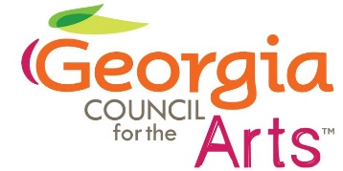

Georgia Council for the Arts
Council Meeting
Feb. 21, 2024

2:00 Call to Order Gladys Wyant
Approve Minutes

2:05 Grants Update Allen Bell

2:15 Grants Panel Introduction Allen Bell

2:30 Arts Education Update Emily Yewell Volin
Teaching Artist Roster
Poet Laureate’s Prize
Poetry Out Loud

2:40 Economic Impact Study Tina Lilly

3:00 Atlanta Art Collaborative Colt Chambers

3:15 Arts Day and Advocacy Tina Lilly

3:30 Adjourn Gladys Wyant

