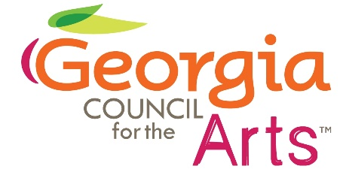

Georgia Council for the Arts
Nov. 6, 2023
Aurora Theatre, Lawrenceville
Minutes

In attendance: Gladys Wyant, Linda Nicholson, Colt Chambers, John White, Maxine Burton, Gina Jeffords, Joanne Chesler
GCA Staff in attendance: Tina Lilly, Allen Bell, Tyrone Webb, Emily Yewell Volin

The meeting was called to order at 1:05 PM
Introductions: Chair Gladys Wyant asked fellow Council members to introduce themselves as there were new Council members.
Minutes: A motion to approve the minutes from the meeting in April, 2023, was made by John White and seconded by Colt Chambers. Motion passed.
Grants: Allen Bell provided a report on grants made thus far in FY24. He reminded the Council that GCA has been able to add additional COVID relief funds to the budget for the last five years, and those funds will be exhausted at the end of FY25.
Tyrone Webb distributed a map of the state showing the counties that received grants in FY24.
Governor’s Awards in the Arts: Tina Lilly said that the tentative date for the Governor’s Awards is December 12 at noon at the Capitol. The Council discussed ideas for future ceremonies.
Advocacy: Tina Lilly reported that Georgians for the Arts would like to schedule an Arts Day during the Legislative Session in 2024. The Council discussed ideas for future Arts Days.
Economic Impact Report: Tina Lilly said that GCA had received its statewide arts economic impact study from Americans for the Arts. She stated that GCA planned to create a one-page document which highlighted key figures from the study as well as other figures that explain the impact of the work that GCA does. The Council provided input on uses for the figures from the study.
Arts Education: Emily Yewell Volin provided an update on the Teaching Artists Roster, Poetry Out Loud and the Poet Laureate’s Prize.
Director’s Report: Tina Lilly reported that GCA was working on a plan to allow people to more easily search the Folk/Traditional Arts Archive. She also reported that the National Endowment for the Arts is auditing GCA. All states that receive NEA funds are being audited, so this is not a result of any errors or mistakes.
Colt Chambers made a motion to adjourn the business meeting, which was seconded by Linda Nicholson. The motion passed.
Council members and GCA staff members were given a tour of the Aurora Theatre.

