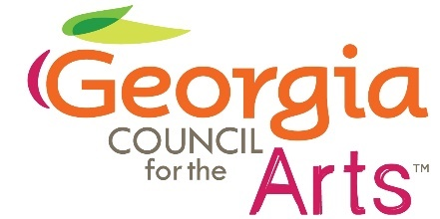

Georgia Council for the Arts
Council Meeting
November 6, 2024
Agenda

1:00 Call to Order Gladys Wyant
Introductions Gladys Wyant

1:15 FY24 Grants Update Allen Bell
Tyrone Webb

1:45 Governor’s Awards Tina Lilly

2:00 Advocacy Tina Lilly

2:15 Economic Impact Study Tina Lilly

2:40 Director’s Report Tina Lilly

2:50 Break

3:00 Tour of Aurora Theatre

4:00 Adjourn

