Queen Emeralda’s

Magical Garden Stories

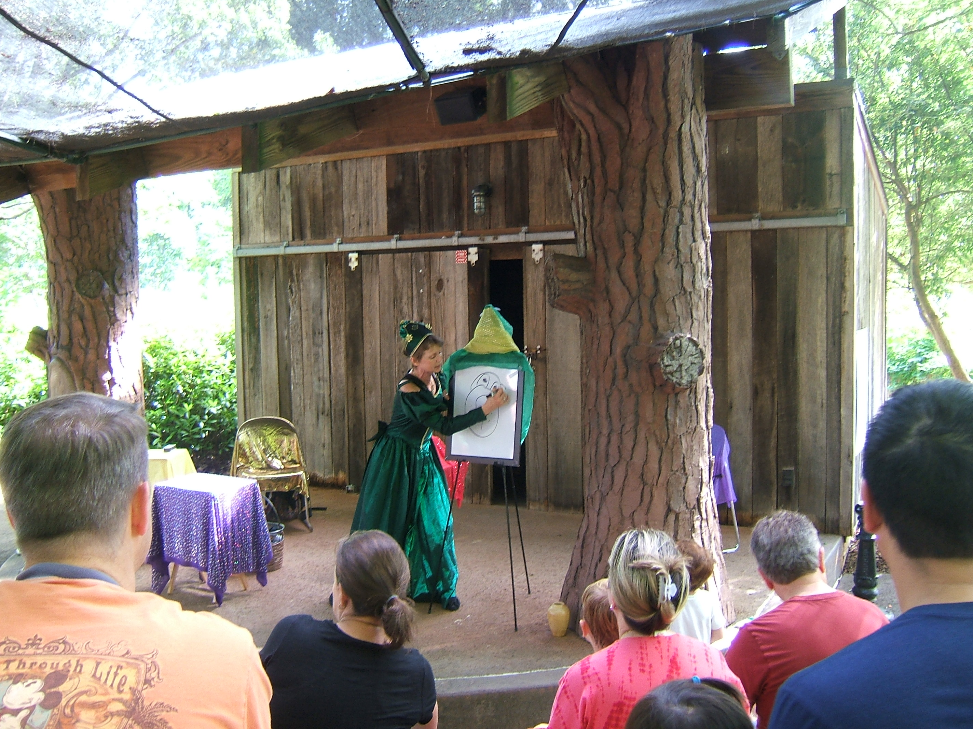

Queen Emeralda is a storyteller from Fairyland.
She will tell and draw magical stories about nature for your students. Her show, “Magical Garden Stories” is full of songs, poems, magic, and puppets. Queen Emeralda’s stories will also emphasize the concepts of ” Big and Little” and “Colors.”

Included here are some of the poems and songs she will use with your students. If they learn them before her visit, they will enjoy participating during the Show.

Program

On the Way Here…a draw and tell story
The Fairy Bell and Magic Flowers
The Sun’s Song……with Sun puppet
A Hawaiian Sun Myth…with audience participation
Garden Poem ….. with audience participation
A Special Guest……and a poem
North American Indian Myth… colors in nature
Sippy & Flap….butterflies
Broom…Big and Little
Little Queenie …dance and folktale
Two Little Apples…action poem
The Picture….a draw and tell story about
jungle animals

Pre-Show Activities

Pre-K
The Beehive Action Poem
All
Sun Song
Hawaiian Sun Story Vocabulary
A Trip to the Garden Action Poem
The Apple Tree Action Poem

Post Show Activities

Make a Sun puppet.
Make butterfly puppets.
Create a torn paper garden.
Create a garden using recyclables

The Beehive

Movement
Here is the beehive,
Make a fist
Where are the bees?
Wiggle fist
Hidden away where nobody sees?
Wave fist
Here they come creeping out of the hive!
Fingers slowly come out
One, two, three, four, five! Buzzzzz!
Pretend fingers are bees

Sun Song

(To the tune of “Row, Row, Row Your Boat”)
Bright sun shining down
Shining on the ground,
What a lovely face you have,
Yellow big and round.

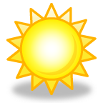

A Hawaiian Sun Myth
Vocabulary:

island canoe

Act Out Being an “island”
Read the definition out loud. Act out what an island is by having one or two students be the island by standing together and making one large shape with their bodies. Other students lie on the ground and are the water surrounding the island.
island – an area of land surrounded by water

Act Out Being a ”canoe”
Read the definition out loud. Four students sit on the ground facing each other with arms extended. Clasp hands to make the point of the canoe. Have another student “get into” the canoe and pretend to paddle.

canoe- a lightweight boat pointed
at each end that can be paddled by one or two people

Art Project for Vocabulary Words

Needed: green, brown and blue crayons; paper

Instructions: Read the definitions of each word to the students. Students should draw a picture based on the descriptions.

island – an area of land surrounded by water
canoe- a lightweight boat pointed
at each end that can be paddled by one or two people

A Trip to the Garden
an action poem
Movement
I went to the garden Make circle with arms
And what did I see? Palms up, hands apart
Two worms crawling along Wiggle pointer fingers
And a buzzing bumblebee. Cross thumbs, flap hands.

I opened a pea pod Palms together, open
And what did I see? Palms up, hands apart
One, two big round peas Make fists
Staring back at me. Look through O’s made
with fingers.

I gave them to a bunny Hands stick up behind head
And what did she do? Palms up, hands apart
She ate the peas! Wrists together, open & shut hands
Now our story’s through. Arms crossed.

APPLE TREE
an action poem
Movement
Two little apples sitting on a tree
(arms out to the side, hands down)
Two little apples smiling up at me. (hands point up)
I shook that tree as hard as I could! (jump)
Down came the apples… (reach down)
Mmmm, they were good! (rub tummy)

