Julie Galle Baggenstoss
julie_galle@yahoo.com
404-277-1499

SAMPLE PROGRAM / MAPPING FLAMENCO
Big Idea: Flamenco arts are influenced by Latin American cultures
Enduring Understanding: Flamenco dance props and music are Spanish with influences from Africa and Asia by way of Latin America
Essential Question: How is Flamenco influenced by cultures outside of Spain?

Standards met
Modern languages and social studies:  Kindergarten: MLEK.CU1, MLEK.CCC1  1st grade: SS1G3, MLE1.CU1, MLE1.CCC1  2nd grade: MLE2.CU, MLE2.CCC1  3rd grade: MLE3.CU1, MLE3.CCC1  4th grade: ML4.CU1, MLE4.CCC1  5th grade: MLE5.CU1, MLE5.CCC1  6th grade: SS6G1,4, SS6H2, SS6G8,11, SS6H6 | 7th grade: SS7G1, SS7G8  8th grade: MLI.CU1, MLI.CCC1, MLII.CU1  9th grade: SSWG2-d, SSWG6-a,c,d, SSWH10-b  10th grade: SSWG2-d, SSWG6-a,c,d, SSWH10-b  11th grade: SSWG2-d, SSWG6-a,c,d, SSWH10-b  12th grade: SSWG2-d, SSWG6-a,c,d, SSWH10-b

Teacher and student preparation
Notify the teaching artist of specific needs within your curriculum goals. The teaching artist will be able to adjust programming to best suit your needs.
Share with students information about the history of Flamenco, the location of Spain and facts about the culture of Spain, as well as the locations of countries covered in this show (see below for maps). Information about Spanish culture can be provided upon request.
Artists provide all sound and stage equipment for this assembly program..
History of flamenco
UNESCO published a fabulous video, slideshow, and written description of flamenco at
http://www.unesco.org/culture/ich/en/RL/00363. This is in response to the organization declaring the art form a part of the Intangible Cultural Heritage of Humanity.
The New Yorker published a video of a young man working as a guitarist in Seville. It shows the side of Flamenco that is often left out of the dialogue about the art form. The video is in Spanish with English subtitles. The video is at http://www.newyorker.com/culture/culture-desk/video-solea-flamenco-seville
Flamenco is an art form of dance, guitar, and song, with Arabic, Indian, European, African, and Latin American influences. At its core, it is an improvised art form that depends on interaction among those making the action happen, as well as the witnesses who help create the excitement. Songs are sung in Spanish, as Flamenco developed in Andalucía. Lyrics portray daily life in Spain, and many times reflect the history of the people who created and popularized the songs.
Vocabulary words for show -- Basic Flamenco words
Jaleos – cheers of encouragement  Manos – hands  Palmas – hands for clapping  Pies – feet  Música – music  Guitarra – guitar  Baile – dance  Cante – song  Emocionado – excited  Enojado – angry  Celoso – jealous  Feliz – happy  Triste – sad  Enamorado – in love  España – Spain | Compás – measure of music  Cierre – ending of dance/music  Marcaje – marking dance steps  Zapateado – footwork of dancers  Toque palmas – hand clapping to accompany  Naranjas – oranges  Cabeza – head  Cuerpo – body  Brazos – arms  Hombros – shoulders  Espalda – back  Apoyo – support  Pollo - chicken  Andalucía – Andalusia

CLASSROOM ACTIVITIES 2 -- SOCIAL STUDIES / MAPPING & TRADE ROUTES

Map skills, geography, history

What do you call the kind of landform on which Spain is located?
What bodies of water surround the Iberian Peninsula? Where is the Atlantic Ocean? The Mediterranean Sea?
Can you imagine the location of the United States of America in relation to Spain?
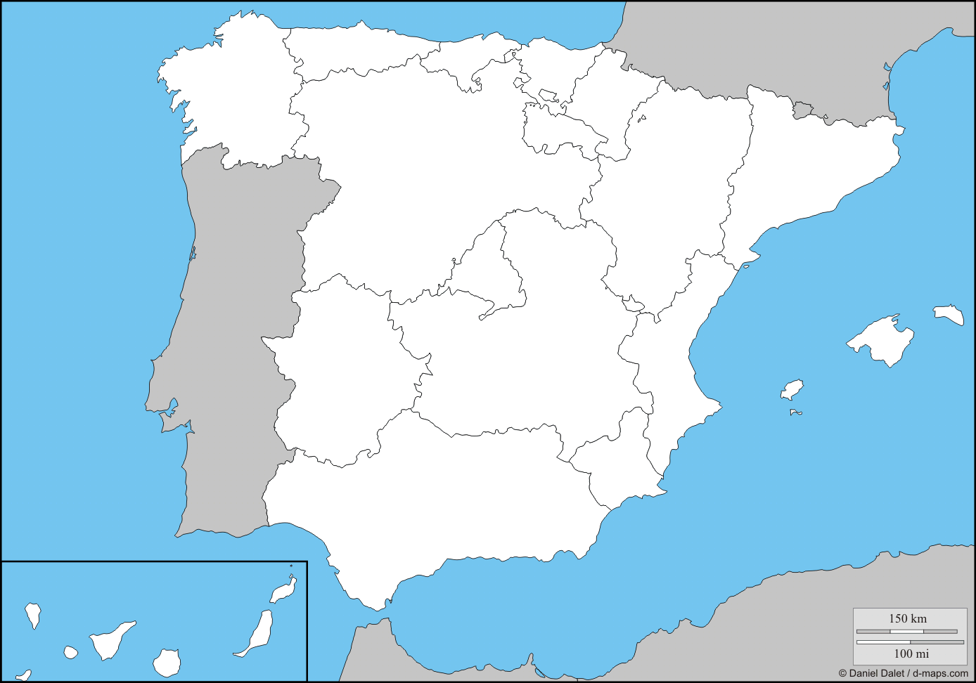
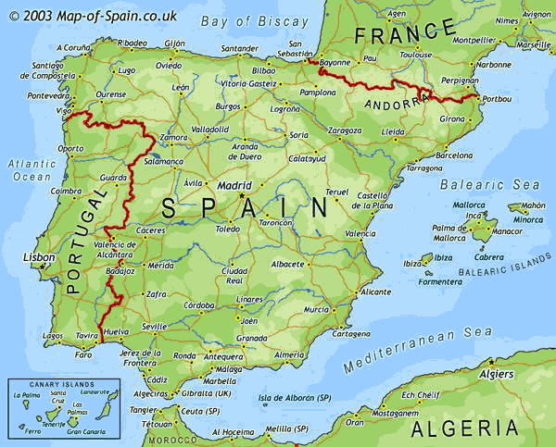
On the blank map below, can you locate the region of Andalucía?
Map skills, geography, history

What is the name of this region of Spain?
Can you identify the cities related to Flamenco?
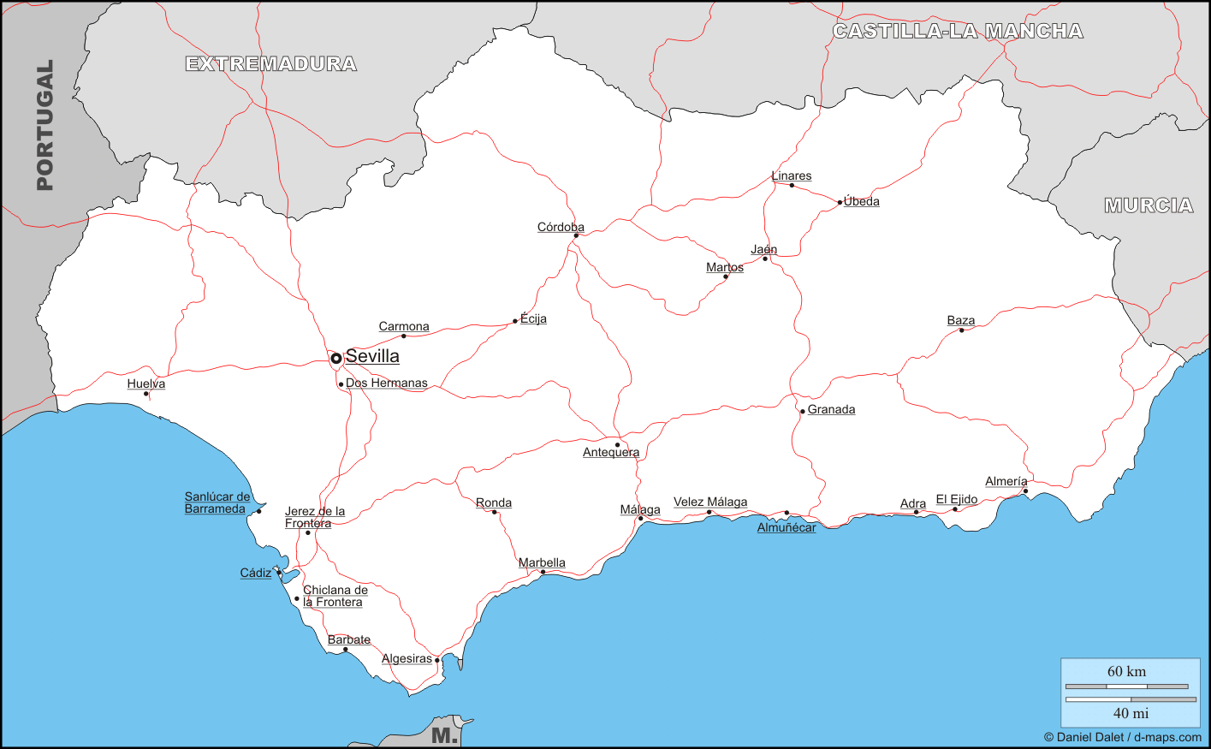
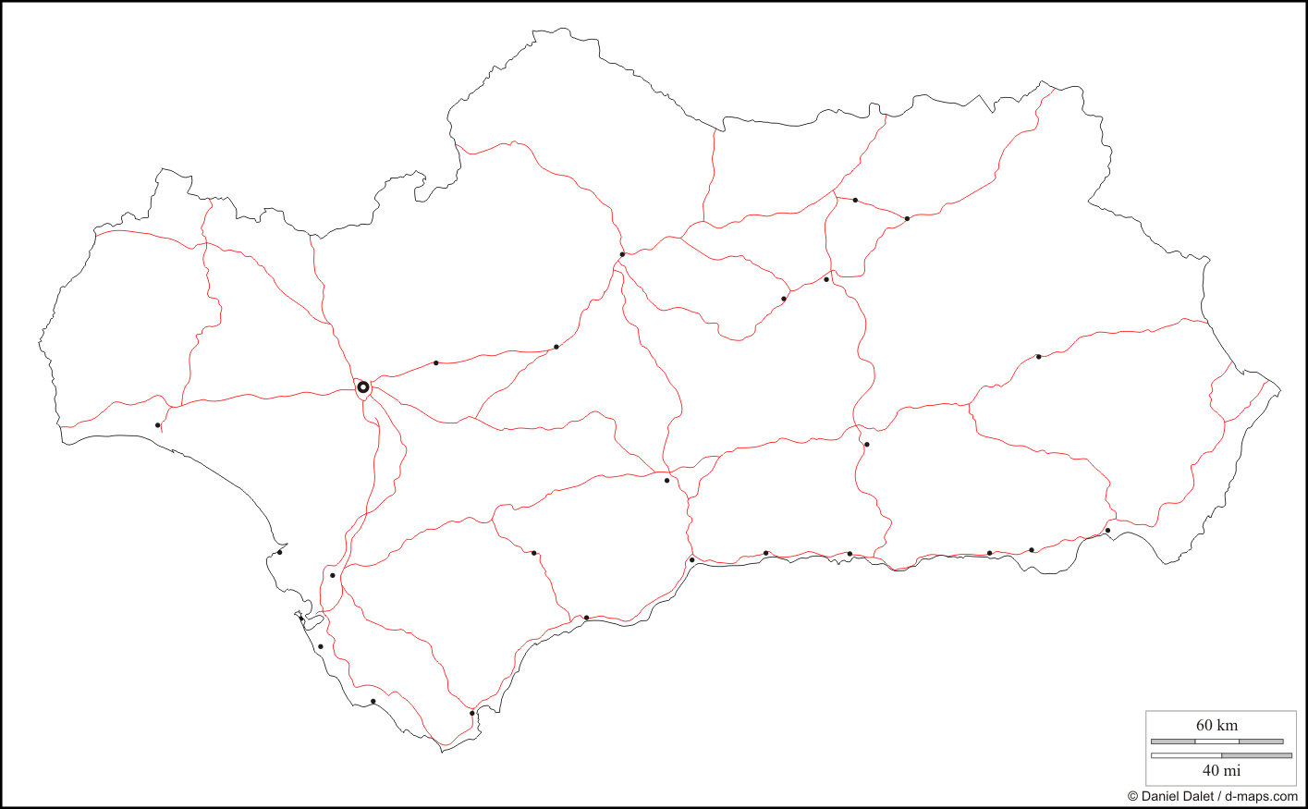

Map skills, geography, history

What is the name of the continent shown in this map?
Where is Spain located in Europe?
Where is Europe located in the world?
Where is the United States of America?
What is the name of the continent on which the U.S.A. is located?
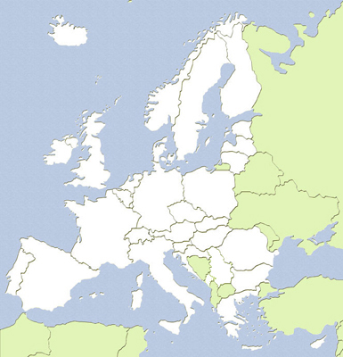
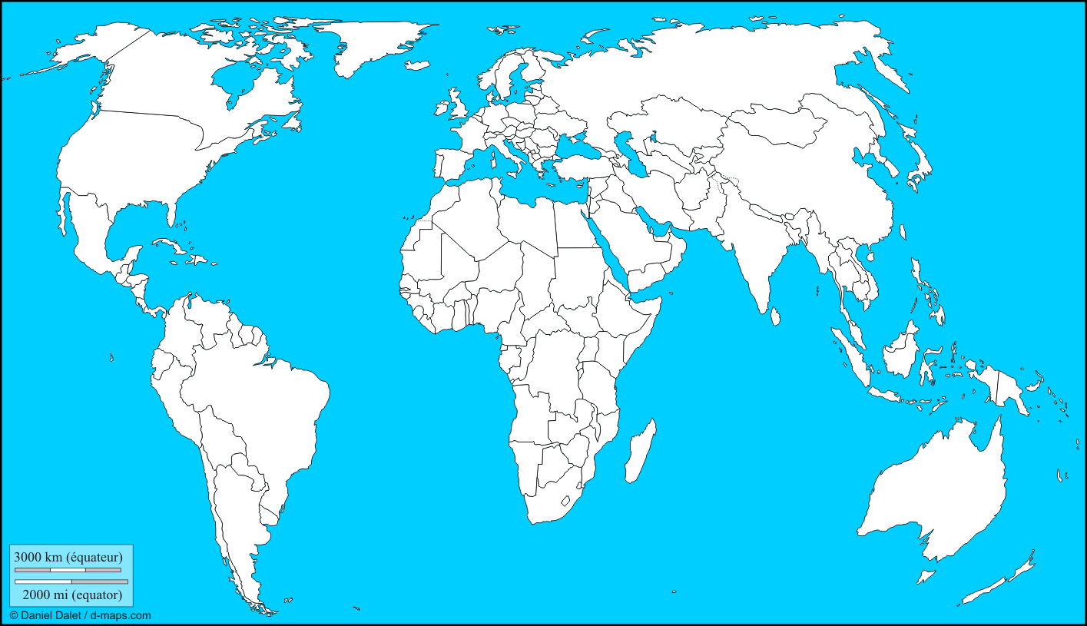
Where are other countries that influenced Flamenco? Can you locate them on the map?

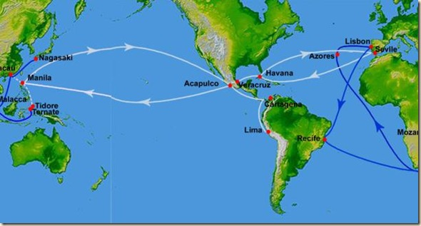

The “Galeón de Manila” and the “Flota de Indias” are shown in white. (Portuguese shipping routes are in blue.)
Where was the Flamenco mantón originally made?
How did the mantón travel from its original location to Spain?
What other information and goods traveled on the trade routes? How did this affect Flamenco?
Go further: View and/or learn to dance Flamenco using a mantón de Manila or learn to dance Flamenco to one of the songs that developed because of the influence of Mexico, Cuba, and Argentina.

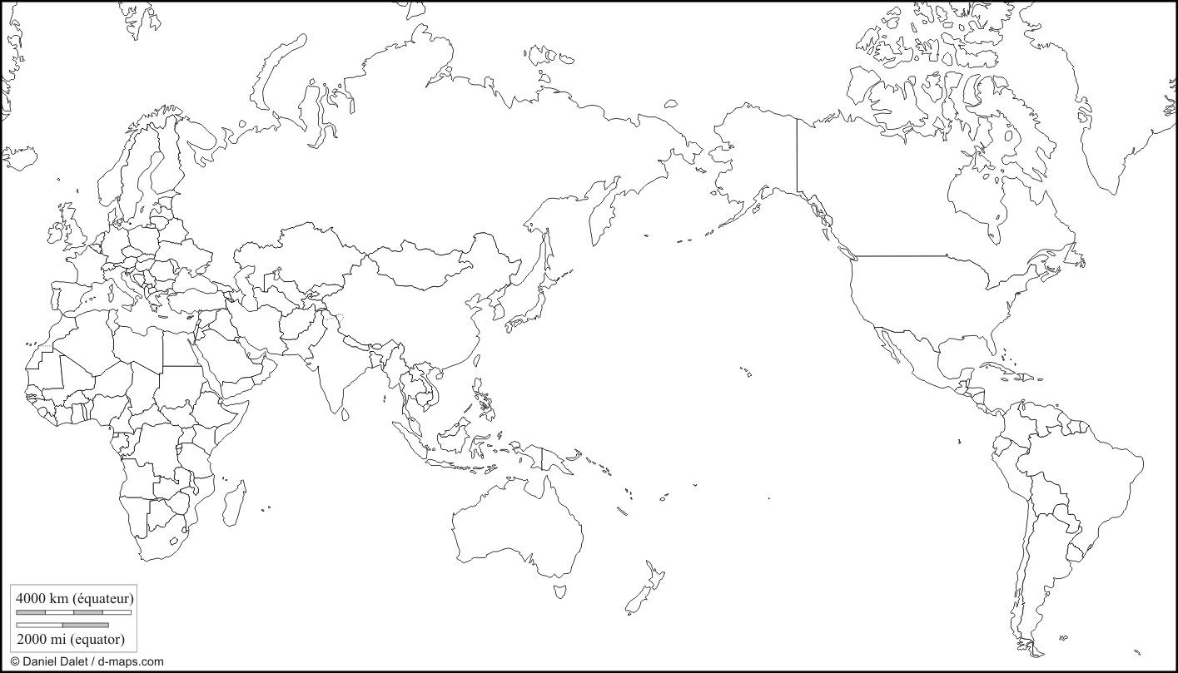
ACTIVITY
Map the trade routes known as the “Galeón de Manila” and the “Flota de Indias”, and label the countries and cities that were major ports along the routes.
CLASSROOM ACTIVITIES 3 – MUSIC CONNECTIONS
In 5 minutes, list as many instruments as you can that are used in the following forms of music:
Flamenco Rumba Cubana Tango of Argentina Punto Cubano Yambú

Using the Internet or books in your school’s library, research these forms of music to get information about instruments with which you are not familiar. List those instruments here and note which ones are string instruments, wind instruments, percussion instruments, etc.
Flamenco Rumba Cubana Tango of Argentina Punto Cubano Yambú

Write the names of these instruments used in Flamenco, rumba Cubano, punto Cubano, and tango of Argentina.

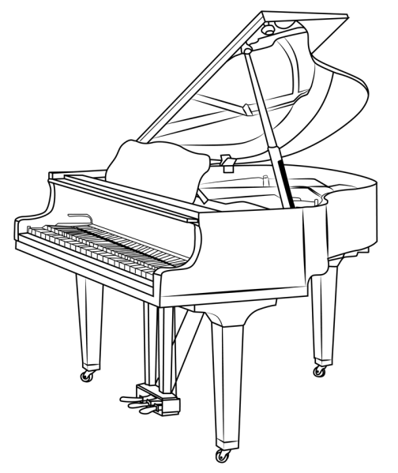
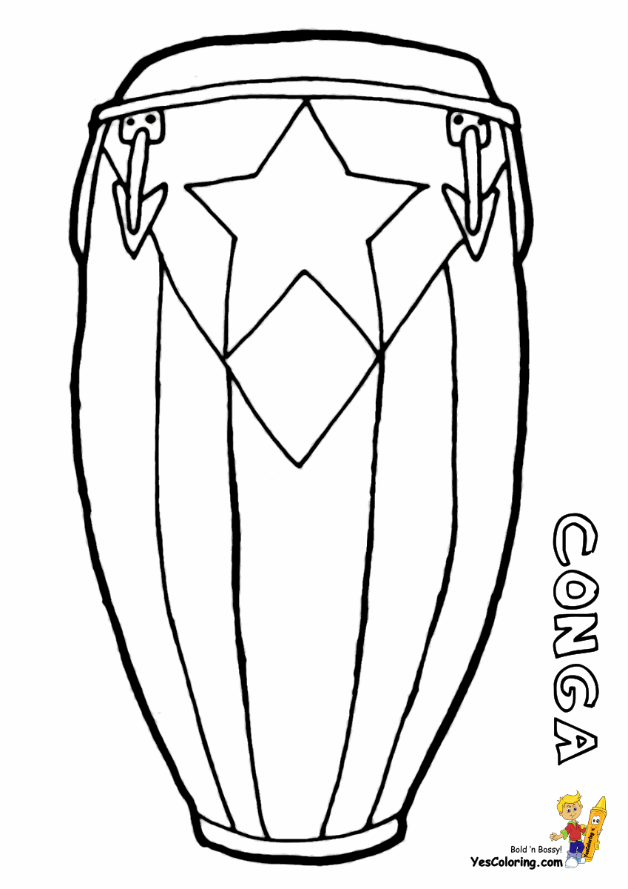
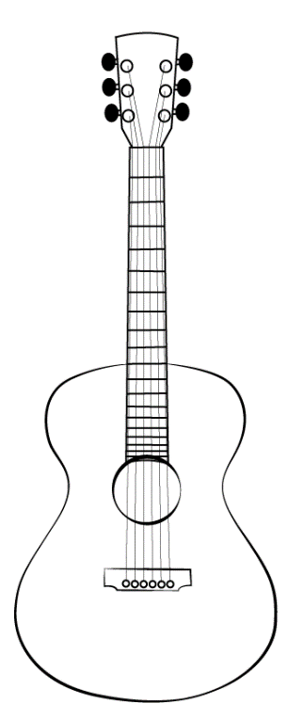
Locate on the map the countries from which Flamenco drew cultural influences. Countries to locate: Angola, Argentina, China, Cuba, Democratic Republic of the Congo, Mexico, United States of America, Uruguay.
Explain how and why people moved between one of those countries to Spain. Was it for reasons of society, war, trade, business, or something else? Can you draw the path of their movement via ships, planes, trains, cars. How would you draw, or write about the movement of arts via these routes, as well as the telephone, film, radio, Internet, etc.?
Countries that influenced Flamenco: Angola, Argentina, China, Cuba, Democratic Republic of the Congo, Mexico, United States of America, Uruguay.

Listen to samples of the following songs and use a Venn diagram to analyze qualities of the Flamenco songs that developed with influence of cultures outside of Spain:
Flamenco song Influencing culture & country Influencing song
Farruca Celtic Tango of Argentina & Uruguay
Tangos Afro-cuban / Congo, Angola, Cuba Rumba Cubano
Guajiras Afro-Cuban / rural Cuba Punto Cubano
Fandangos Mexico / Indies Traditional African & Indigenous
American
Rumba Afro-Cuban rural Cuba Yambú
VENN DIAGRAM
Use this chart to compare characteristics of Flamenco and film in different time periods. Consider rhythmic accents, time signature, instruments, language, subject matter of lyrics, and other cultural and musical factors.
Different Same Different

