A Company of Friends Educational Productions Established in 1999 Presents their 2017 Prehistoric Touring Musical
The Big Bad Bullysaurus
By Tommy Jamerson / Song Lyrics By Tammy Barton
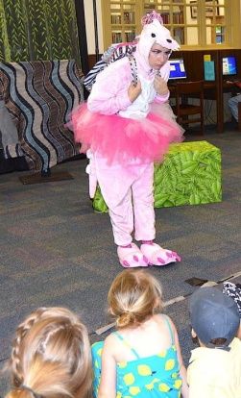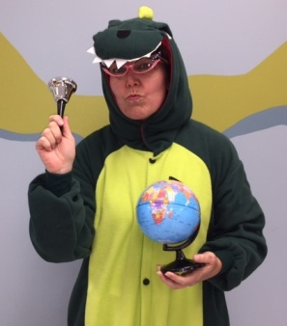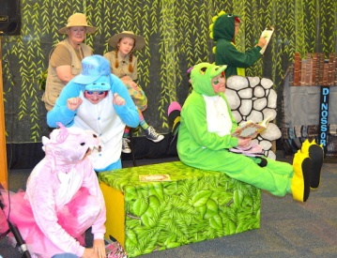
When Paleontologist Misty learns that her niece, Natalie, is being harassed by a local bully, she tells her the story of Roxy Rex, a young and posh dinosaur with a bully problem of her own. During this live musical play audiences journey back in time to Dinosorri Elementary School and watch while Roxy Rex and Natalie both learn a lesson about friendship and the importance of forgiveness. Filled with heart and humor and four original songs that add sparkle, The Big Bad Bullysaurus entertains audiences while touching on a very timely issue. *Six Professional Actors *Professional Sound Support *Creative Sets *Colorful and Unique Costumes *Audience Interaction *Study Guides Available *Show runs 50- minutes *Great for ages 4 to 12 years
A Company of Friends Educational Productions has been bringing quality, educational and musical theatre experiences to Library Reading Programs and Schools since 1999. ACOF is a former member of Atlanta Young Audiences and currently on the Georgia Council for the Arts Touring Artists Roster.
Please turn flyer over for prices and booking information!

Bring the Dinosaurs To Your Location
*1 Performance: $585 *2 Performances: $785 *3 Performances: $885
Locations farther than 30 miles, one way, from Peachtree City, Georgia require a gas allowance of .65 per mile added to base fee of show price.
Locations farther than 50 miles, one way, from Peachtree City require a hotel stay and gas allowance added to the base fee of show price of .65 cents per mile and $80.00 a night for hotel.
Schedule your Dinosaur visit today….. Call 770 – 599-0051 or e-mail acofdirector1@gmail.com 