Story Quilt Quilting Bee
Cobb County Professional Learning Workshop- Winter 2018
High Museum of Art-Atlanta
Developed by: Marquetta Johnson- Teaching Artist

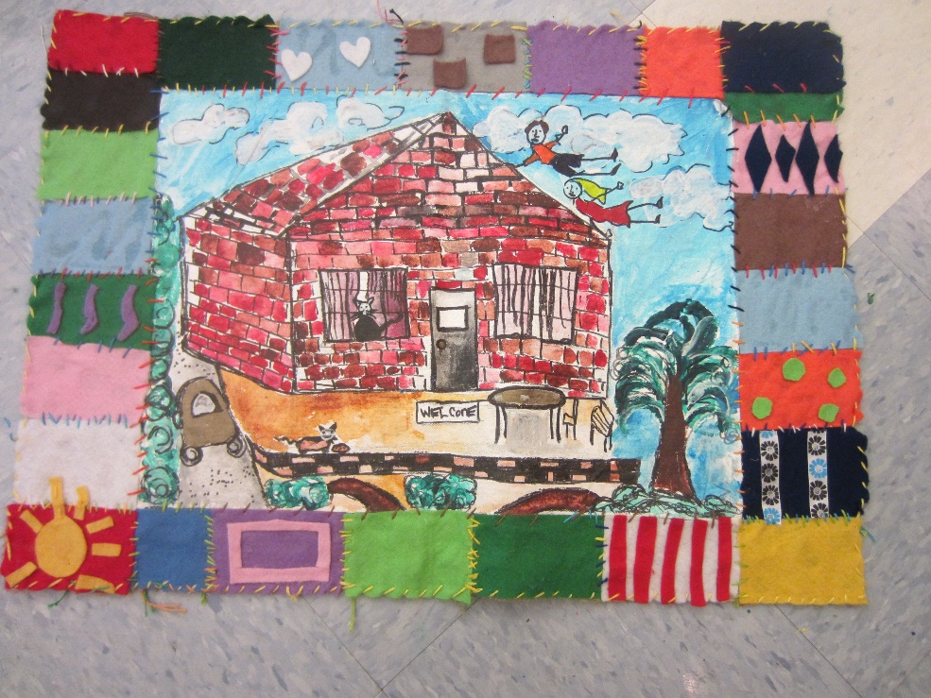

Established Goals

VAK-5PR.2 Understands and applies media, techniques, and processes of two-dimensional works of art (e.g., drawing, painting, printmaking, mixed media) using tools and materials in a safe and appropriate manner to develop skills.
g. Develops manual dexterity though craft techniques (e.g., collage, stitchery, weaving).

Essential Questions

- How can a story be told with line, shape, color and texture?
- How can an artist create movement, balance and repetition in their artwork?
- What is the value of hand crafted objects in our lives?

Objectives:

Participants will understand:
- How line, shape and color can communicate a thought or an emotion
- The difference between a traditional quilt and an art quilt
- How the Elements of Art And the Principles of Design are used in the creation of quilts
Participants will be able to:
- Safely and appropriately use art materials and equipment
- Sew a running stitch
Participants will appreciate:
- The beauty of handmade textiles
- The beautiful results that come from using artist grade materials

Performance Tasks:
- Participants will develop a story line to inspire an idea for a drawing
- Participants will explore drawing on canvas sheets
- Participants execute basic quilting techniques

Key Criteria: Development of a Mini Story Quilt incorporating Elements of Art and Principles of Design

Materials:
Canvas Sheets
Sharpie Markers
2”Fabric Squares
Embroidery Floss
12” x 12” Burlap Squares
Tacky Glue
Sequins
Buttons
Scissors

Advanced Prep:
Cut fabric into 2” squares
Cut burlap into 12”x 12” pieces

Lead-in: Many Visual Artists are exploring how they can share their personal stories in their artwork. Quilters all over the world are inspired by the story quilts of Ms. Faith Ringgold, a contemporary American artist that uses the process of quilting, drawing and painting to share her own personal stories and historical narratives. Today we will create a story quilt using adapted methods for the classroom.

Teaching Approach:
Open Studio

Lesson Summary

This lesson is an introduction to Story Quilts and a simple way to bring them into the classroom. We will divide this lesson into two parts-Drawing the story panel and sewing and/or gluing the quilt. The Teaching Artist will be explaining in detail the definitions and characteristics of each process. Participants will examine, explore and experience multiple media and processes.

Accessibility Notes
Participants with visual impairments or disabilities may need modified handouts and processes.

Mini Glossary:

Organic line: a mark with length and direction that forms an irregular shape, or one that might be found in nature, rather than a regular, mechanical shape

Inorganic line: a mark with length and direction that is straight and forms a geometric shape

Shape: a form that refers to the distance or area between, around, above, below, or within an element or part of an element

Geometric shape: any shape or form having a more mathematic than organic design. Geometric designs are typically made with straight lines or shapes from geometry, including circles, ovals, triangles, rectangles, squares, and other quadrilaterals

Repetition: a principle of design; refers to a way of combining elements of art so that the same elements are used over and over again

Rhythm: a principle of design; refers to a way of combining elements of art to produce the look and feel of movement, especially with a visual tempo or beat

Pattern: a form or model proposed for imitation

Color: an element of art with three properties:

Hue or Tint: the color name (e.g., red, yellow, blue, etc.)

Intensity: the purity and strength of a color (e.g., bright red or dull red)

Value: the lightness or darkness of a color

Process:
- Participants use assorted colors of Sharpie Markers to create detailed drawings that use line, shape and color to tell the story of a moment in time in the life of the participant or a moment in history. Text may be added, however, it is optional.
- Participants glue their drawing onto the middle of a piece of 12” x 12” Burlap
- Participants surround the centerpiece with sewn or glued 2” squares.
- Participants add sewn or hot glued decorative elements to complete the Story Quilt

Reflect
Ask participants what they felt when art-making.
What art materials and/or processes were most enjoyable? Most Challenging?

