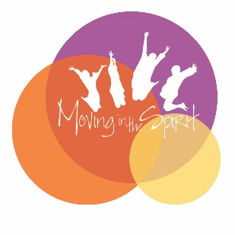
- Title:
My voice—a workshop on diversity and inclusion

- Primary Art Form:
Dance

- Grade Level:
High School

- Experience Summary
Diversity and inclusion are values that students hear about all the time, but school systems often fail to provide the character development training students need to develop empathy in the face of difference. Following the Positive Youth Development model, this workshop will provide educators with a framework for cultivating understanding through creativity. The workshop’s curriculum will use current news headlines to create issue based choreography. This workshop combines social studies (analysis of current events) with language arts (creative writing) and the performing arts (creative movement) to create a comprehensive framework for uniting different perspectives and modeling positive behaviors.
After an initial group check in, workshop participants will write a creative journal entry about the ways in which a current event/issue affects them personally. Participants will identify five action verbs in their writing related to the emotional struggle and five descriptive adjectives of personal qualities. Participants will then assign a corresponding movement gesture for each verb and adjective, and combine these gestures into a short sequence. After performing their gesture sequences in small groups, the entire group will come together to dialogue about the emotions they understood and connected with as they witnessed each other’s creative movement. During the dialogue, instructors will prompt analysis of the Creative Youth Development modeled behaviors- whether the dancer approached her challenges assertively (the positive behavior), aggressively, passively, or passive aggressively (negative behaviors). The goal of the workshop is for participants to understand how creative processes help them better identify, communicate and understand their perspective of the world around them.
Workshop Objectives - By the end of this workshop, participants will be able to:
- Engage high school students with a pressing social issue causing stress or tension, or a situation of discrimination
- Lead students in a creative process of writing and generating movement to better identify, communicate and understand their perspective of the world around them.
- Lead a dialogue between students to behaviors as a model for promoting tolerance in their own lives
Essential Question:
This workshop perfectly exemplifies the transformation of young people that is possible through the arts. Participating in a creative process themselves helps them understand how creative writing and movement facilitate communication. The arts unite people of all backgrounds, and young people need to participate firsthand to gain skills of tolerance and equality. By working creatively to understand movement as a part of communication, students will practice behaviors of empathizing with their peers and dealing with situations of difference. Cultivating empathy, patience, and clear communication in the face of difference is the essence of transformation that our young people need to succeed in school and the workforce. Our communities are transformed by the positive impact of young people actively engaged in facing down discrimination and promoting tolerance.

- Student Teacher Ratio
2 teachers to 18 students
- Workshop Length:

2 hours

- Fee Structure:

$500 per workshop, open for negotiations

- Standards
Common Core Standards:
CCSS.ELA-LITERACY.CCRA.SL.1
Prepare for and participate effectively in a range of conversations and collaborations with diverse partners, building on others' ideas and expressing their own clearly and persuasively.
CCSS.ELA-LITERACY.CCRA.SL.2
Integrate and evaluate information presented in diverse media and formats, including visually, quantitatively, and orally.
National Arts Standards:
Anchor Standard #10: Synthesize and relate knowledge and personal experience to make art
Anchor Standard #11: Relate artistic ideas and works with societal, cultural, and historical context to deepen understanding

