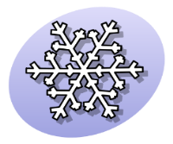
Queen Snowflake’s
Winter Study Guide by Kay Rosenblum
Winter Facts:
- Winter days are short.
- Winter nights are long.
- The earth spins on a tilt.
When the Northern hemisphere is tilted away from the sun, it is Winter; in the Southern hemisphere, it is Summer.
http://www.22facts.com/winter/, http://spaceplace.nasa.gov/seasons/en/

- DECIDUOUS TREES
(change with the seasons)
Cut out these trees and labels. Mix them up.
Students match and order.

Summer Fall
Spring Winter
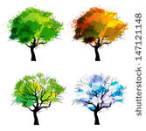
- CONIFER TREES (stay green every season)
Big and tall
Skinny and small
Conifer trees are always green,
That’s all.

COLOR THE TREES GREEN.
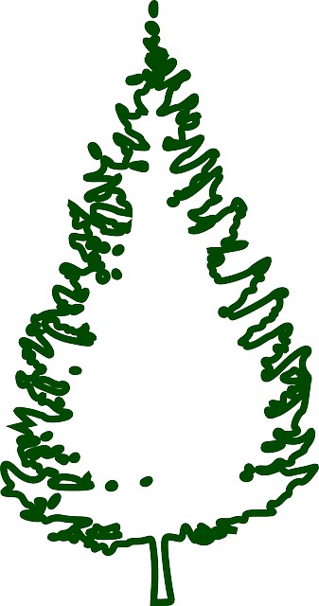

To help Queen Snowflake with Winter Magic
LEARN THESE SONGS:

Both songs are to the tune of “Frere Jaques” or
“Are You Sleeping”

Are you sleeping, are you sleeping?
Brother John, Brother John?
Morning bells are ringing, morning bells are ringing
Ding ding dong, ding ding dong.

SNOWFLAKE SONG
Dance like snowflakes,
Dance like snowflakes,
In the air, in the air
Twirling, whirling snowflakes
Twirling, whirling snowflakes
Here and there, here and there.

SLEEPING BEAR SONG
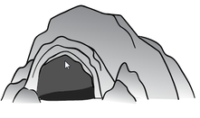
Bear is sleeping, Bear is sleeping.
In a cave, in a cave.
I wonder when he’ll come out
I wonder when he’ll come out.
In the spring, in the Spring.

ACT OUT ANIMALS
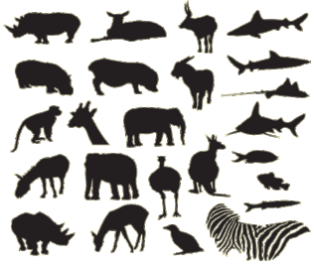

Choose Migrating or Hibernating Animals.
Tell the class which kind of animals they’ll be acting out. Encourage the use of movement and sound. Actors can show the animals eating their food, sleeping, building a nest or other activity the animal they are portraying would do in the wild.

Ways to Act Out Animals:

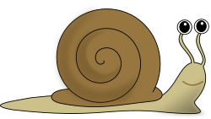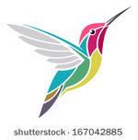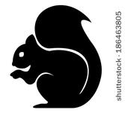

1. One student is selected to be the guesser.
They go into the hall or cover their ears so they can’t hear the class choose one animals to act out.
Everyone else acts out the chosen animal and the guesser makes a guess. If they are having trouble figuring out what animal is being acted out, clues can be given. (This animals has fur. This animal lives in the water, etc.)

2. Ask one student to act out an animal and the class guesses.

3. Assign one animal to a small group of students (2-4) and they work together to make a presentation to the class. The class guesses their animal.

Act Out These Hibernating Animals
What better way to spend the winter than to sleep?
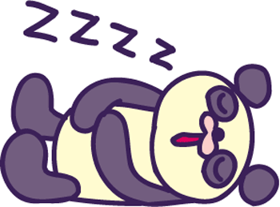
ground squirrels, snails, garter snake, skunks, queen bumblebees (worker bees and males die), frogs, box turtles, earthworms, bats, bears, lemurs
http://www.earthrangers.com/wildwire/top-10/top-ten-hibernating-animals/

Act Out These Migrating Animals
Maybe it would be best to find a warmer place to spend the winter.
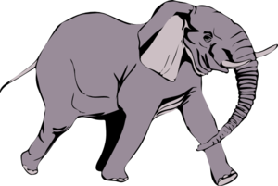
Canada goose, ducks, moose, whales, caribou, African elephant, sea turtle, hummingbird, zebra,
hammerhead shark
http://www.enchantedlearning.com/coloring/migrate.shtml
COUNT AND COLOR

Every snowflake has 6 sides. Take 6 different crayons and color each branch a different color.

Act out Winter Time Activities
Cut out and take turns picking, acting out, and guessing the pictured activities. What other Winter time activities can your students name? Make a list.

Build a snowman Put on a hat, scarf
and mittens.
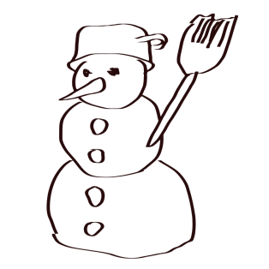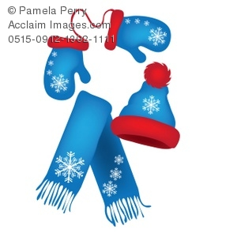

Be in a blizzard Shovel snow
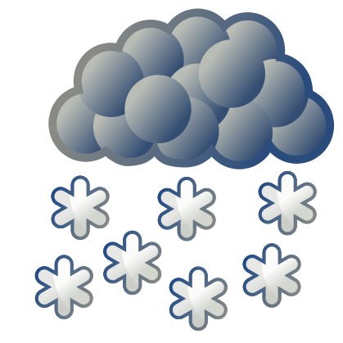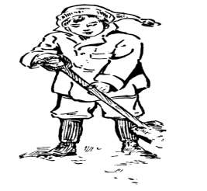

Build an igloo Sled down a hill

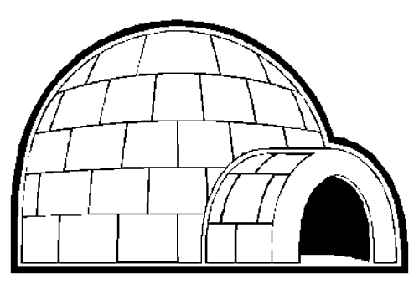

Skate Snowboard
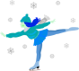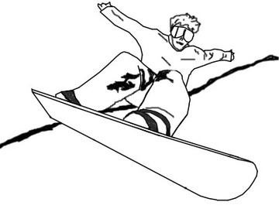

Ski Ride a dog sled

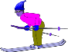
Georgia Performance Standards Used
SKCS5. . a. Describe and compare things in terms of number.
SKCS2.. a. Use whole numbers for counting, identifying, and describing things and experiences.
SKCS4. a. Use a model—such as a toy or a picture—to describe a feature of the primary thing.
SKE1.. c. Recognize that the Sun supplies heat and light to Earth.
S1CS5.. a. Describe and compare things in terms of number, shape, texture, size, weight, color, and motion.
S1E1. a. Identify different types of weather and the characteristics of each type.
S1E2.. a. Recognize changes in water when it freezes (ice) and when it melts (water). b. Identify forms of precipitation such as rain, snow, sleet, and hailstones as either solid (ice) or liquid (water).
S1L1. a. Identify the basic needs of a plant. 1. Air 2. Water 3. Light 4. Nutrients b. Identify the basic needs of an animal. 1. Air 2. Water 3. Food 4. Shelter c. Identify the parts of a plant—root, stem, leaf, and flower.
S2CS2. a. Use whole numbers in ordering, counting, identifying, measuring, and describing things and experiences.
S2CS5. a. Describe and compare things in terms of number, shape, texture, size, weight, color, and motion
S2E2. Students will investigate the position of sun and moon to show patterns throughout the year.. c. Relate the length of the day and night to the change in seasons (for example: Days are longer than the night in the summer
S2L1. Students will investigate the life cycles of different living organisms. a. Determine the sequence of the life cycle of common animals in your area: a mammal such as a cat or dog or classroom pet, a bird such as a chicken, an amphibian such as a frog, and an insect such as a butterfly.

