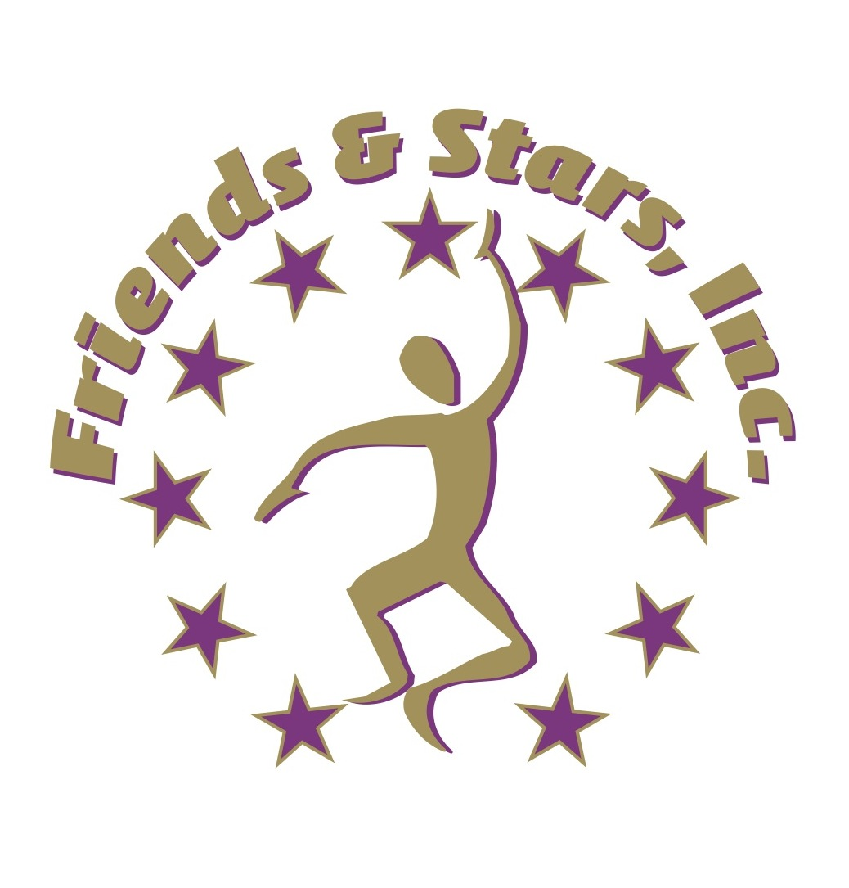

A Caring Community Supporting the
ARTS & DISABILITIES

Friends & Stars, Inc. is a 501(c)(3) nonprofit organization that provides unique, pioneering arts programming expressly
designed to be all inclusive of the senior, adult and children special needs populations. Professional art instructors offer
therapeutic art expressions for people of all abilities in an atmosphere of dignity, respect and friendship.

Proposal for Artistic Services for Children, Youth & Senior Programs

Project Title: FRIENDS @ ART: LEARNING WITH AN ARTFUL TOUCH

Project Summary: FRIENDS @ ART: LEARNING WITH AN ARTFUL TOUCH is a collaboration between Friends & Stars, Inc., Broward County’s premier non-profit for arts programs, and the City of Lauderhill Children, Youth & Senior Services. It will provide creative arts projects and implement knowledge of the arts, unique art projects, specialty art designs and exhibit opportunities for Children, Youth & Senior Services’ expressed needs:
1) to raise art competencies in the application of best practices for developing arts-integrated learning projects from concept to completion for children, youth and children, youth and seniors, and
2) to deliver arts-based learning activities to children, youth and seniors through socially relevant theme-based visual arts projects.

We will provide
1) one day per week (104 weeks) of specialty art classes designed for a senior population, minus official City holidays and closed days at the Sadkin Center;
2) one art exhibit for the children, youth and seniors in major art galleries (2 exhibits per year), including 1 art exhibit at the Senior Center, and
3) fifty-two site visits to the art center for specific instruction for children, youth and seniors to work in a fully functioning art center on projects followed by consultation for guiding methods of application.
4) 2-hour interval segments with all supplies included.

Development classes will include 1) Introduction to Drawing & Chalk Pastels, 2) Acrylic Painting using various techniques: wet on wet, brushstrokes, palette knife, finger painting, and 3) participation in an instructional sampling of related hands-on activities which will include using recycled materials to create art.
The workshops will be strategically scheduled over a period of six months to insure successful project planning and implementation. As a result of this program the Children, youth and seniors will be able to share and explain to other non participating members at their centers about their projects, thereby furthering the Division's efforts to build learning competencies and raise the frequency and standards of arts-based learning programs especially designed for Children, youth and seniors.

Amount Requested: $104,000 ($52,000 per year for 2 years)
Breakdown: $20.00 per person x 2 hr session (Rate: $10.00 per hour)

Project Location(s) and Address(es):
City of Lauderhill - Leisure Services @ SADKIN CENTER Friends & Stars, Inc., Art Center
SR 7 1176 N W 42nd Way, Lauderhill, FL 33313, and 4603 N. University Dr., Lauderhill, Fl 33351

And other designated location; Boys & Girls Club of Lauderhill, Parks & Recreation Centers, etc.

Commissioner Districts Served: 9 Florida House of Representative Districts Served 94
94 - Rep. Perry E. Thurston, Jr. Minority Leader
Florida Senate Districts Served 31
31 - Senator Christopher L. Smith

Project Start Date: October, 2016 Project End Date: September, 2018

PROJECT DETAILS Describe Target Population:

The target population includes a community population of at risk / underserved children, youth and 25 seniors. There will be several blocks of children given the opportunity to engage in the arts through their after-school program generated by the City of Lauderhill. The Block Grant program / City of Lauderhill are in charge of livelong learning activities for children, youth and seniors.

Why Is This Project Needed?

Many of our elderly citizens come from low income households, many are no longer employed, had jobs that did not afford them a handsome retirement, extended family caretakers managing child care, and lack of cultural enrichment or support mechanisms for developing higher creative thinking skills, budgetary restrictions and traditional programs have maintained the role of park center staff as care takers who provide games, sports, crafts and occasional museum field trips. With trending declines of arts education in schools, parks departments need to expand their role as providers of cultural enrichment that impacts social and academic growth by providing added-value learning through qualified arts integrated programs.

With FRIENDS @ Art - Learning with an Artful Touch having established foundational knowledge and best practices for creating appreciation of self art and for artwork created by others, arts-based curricula, administration and participating staff feedback will indicate 1) an increased appreciation of and readiness to develop arts for learning in senior programs, 2) a need to raise the quality and frequency of arts integrated learning activities, 3) a need to advance art skills of children, youth and seniors, 4) a need for expert technical assistance to put theory into practice for children, youth and seniors.

What are the Goals and Objectives of the Project?

FRIENDS @ Art - Learning with an Artful Touch

GOALS:
1. To build art skills for children, youth and seniors in the application of foundational knowledge for designing and implementing their own integrated arts projects;
2. To provide expert guidance and technical assistance for project development that serves cultural enrichment, higher level thinking skills and new ways of expression for children, youth and seniors.

OBJECTIVES:
1. To conduct weekly art classes especially designed for children, youth and seniors of the Sadkin Center;
2. To assess group and centered learning;
3. To review and reinforce fundamental knowledge and understanding of arts-based learning and cultural enrichment: project planning, best practices and teaching strategies;
4. To raise competency levels of the participants in developing theme-based arts for learning activities from concept to completion;
5. To demonstrate interactive games and art exercises that promote higher level thinking skills, creative expression, communication, team building, cooperation and self-esteem.
6. To development and implement appreciation of self art and art of others.

How many will be Directly Served

_____ Leisure Services full time staff: 1 coordinator, 3 supervisors, and 2 aides. ______ community participants: 30 children, youth and seniors representing the Sadkin Center.

How many will be Indirectly Served

______ A community population of ____ children, youth and seniors, staff providers serving Sadkin Center.

~~~~~~~~~~~~~~~~~~~~~~~~~~~~~~~~~~~~~~~~~~~~~~~~~~~~~~~~~~~~~~~~~~~~~~~~~
Visit our Art Center located at 4603 N. University Dr., Lauderhill, Fl 33351
(954) 440-3687

Facebook: Circle of Friends & Stars
Website: www.artsanddisabilities.org
Email: cofriendsandstars@gmail.com

