Narrative Necklaces
Self-Portraits with symbols, text and imagery!

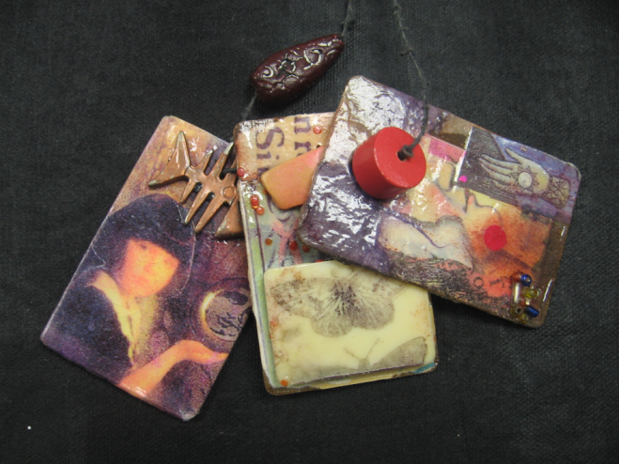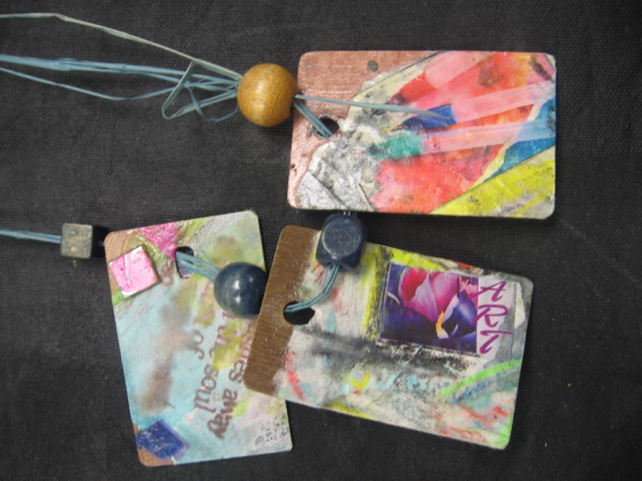
Some Questions to Consider
- What is your favorite color? __________________________
- What is your favorite sport? __________________________
- What is your favorite class? ___________________________
- What is your favorite hobby? __________________________
- What is your favorite food? ___________________________
- What is your favorite thing to do on the weekends? _________________________________
- What is your talent? _______________________
- How would others describe you? _______________________

…think of some other interesting and unique traits that you possess…
I can’t wait to get to know YOU better!

