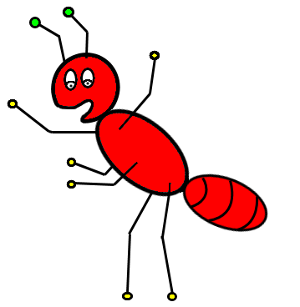INSECTS
ARE
EVERYWHERE
An Acting Adventure!
by Kay Rosenblum
For Pre-K through 2nd grade

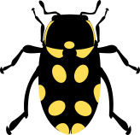

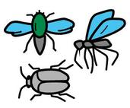

INSECTS ARE EVERYWHERE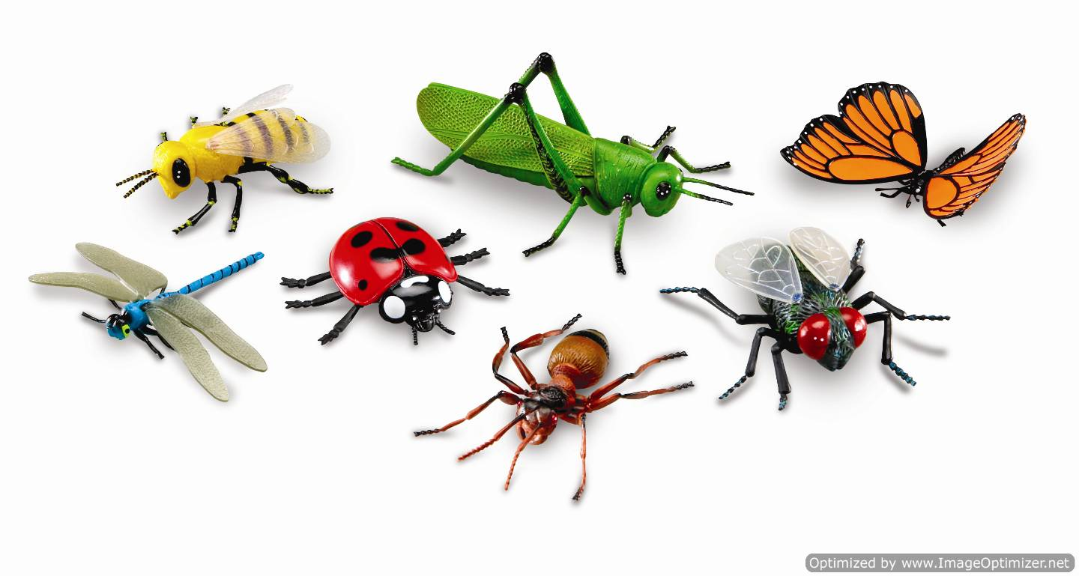 A Classroom Acting Adventure
by Kay Rosenblum
For Pre-K through 2nd grade

Follow the script and add action.

Action: Pretend to put on hats. Show pictures as needed.
Script:
Let’s be Entomologists and find out about insects. Reach way up to your Imagination Shelf (PRETEND!) and get a hat with a wide brim and put it on your head.

You need a hat because you’re going to be outside looking for a SAHARA DESERT ANT and you don’t want to get a sunburn!

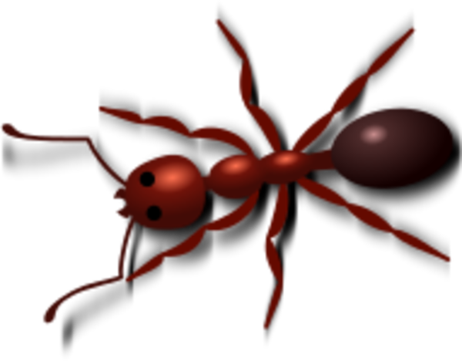

But wait! Some insects live underwater. Take off your hat and put on your snorkel. A snorkel helps you breathe underwater. Now you can find a DIVING BEETLE.

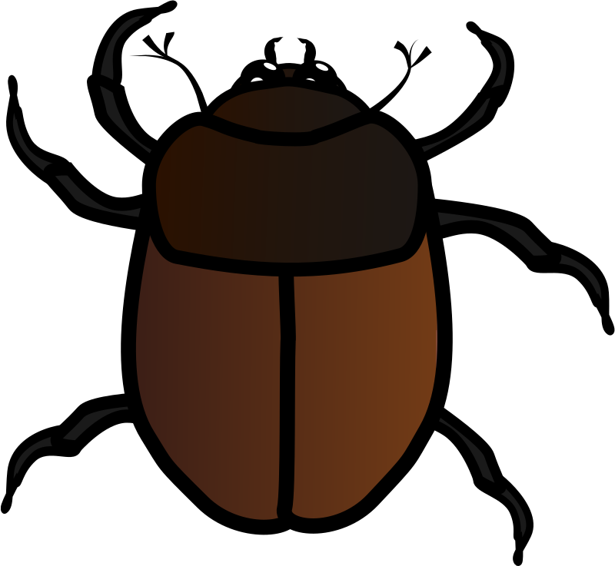

But wait! Types of bumblebees live where it’s really cold and have really thick coats of hair in order to survive. We’re going to need a warm hats. Take off your snorkel and find a warm hat on your imagination shelf. Put on your warm hat to go to the North Pole to find the ARCTIC BUMBLEBEE.

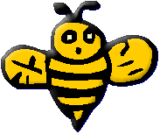

Insects are all over the world, so, you can pick any hat you want and put it on and pretend to be anywhere you want to be and you will probably find an insect. Insects are even inside our homes so you might not even need a hat! What kind of hat will you choose?

ACTION: Pick out one of these hats or any hat from your
Imagination Shelf.

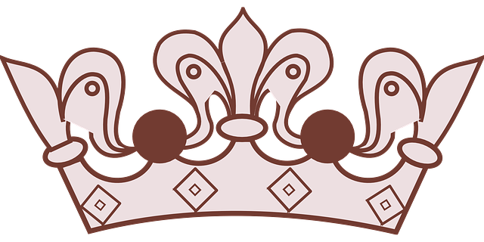

ACTION:
Now look around you. Can you PRETEND to see any insects flying or hopping or crawling around you?

What insects do you see?

MAKE A LIST OF INSETS based on students’ answers.
Continue to add to it as you go through the activities.

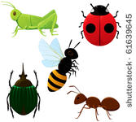

ACT OUT INSECTS
These actions can be done in a small space next to your desk or are meant to be done “in place,” perhaps by the side of the desk. Depending on space, you may find it best to let half the class do this exercise at a time. They’ll have more space to move around in and students will have a chance to hear the material twice as well as see their classmates acting.

Be an ATLAS MOTH. Be as big as you can be. You’re 11” wide and you are the biggest insect. But you are slow. Flap your wings slowly.

Be a FAIRYFLY. You are the tiniest insect. How small can you get?

Be a LADY BUG. Round but with hidden wings.

Be a STICK BUG You are skinny and long.

Be a HORNED DUNG BEETLE You are the strongest insect and can pull 1,141 times your own weight. Pretend to pull a refrigerator. An elephant. An airplane.

Be a FLEA. The highest jumper. How high can you jump?

Be a TIGER BEETLE. Run in place because you are now
the fastest insect runner.

Be a BEE Buzz. Make a figure 8 with your head.

Be a PONDSKATER and skate (in place) on top of water.

MOVE LIKE INSECTS 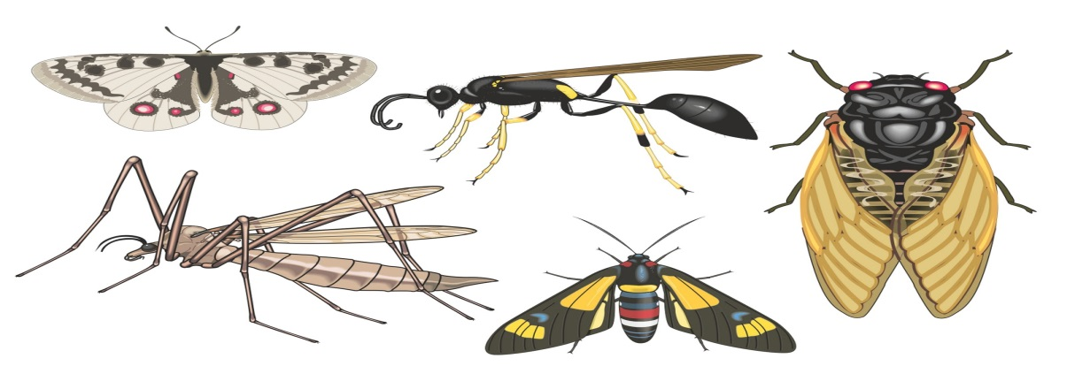

These movements are meant to be done moving slowly around the room.

TEACHER’S SCRIPT:
We’re gliding, gliding, gliding, FREEZE! Now look around and see everyone else’s frozen statue of a gliding insect. We’re leaping, leaping, leaping, FREEZE! Look around at everyone’s leaping insect statue. We’re building, building, building, FREEZE!
Do the same for “walking upside down,” “fluttering,” “stinging,” “ sipping nectar from a flower,” “wiggling.”

REFERENCES:

Ross, Norman, P., ed. and Lincoln Barnett. The Wonders of Life on Earth. New York: Time Inc., 1960.
Berry, C.E., ed. A Child’s First Library of Learning, Insect World. Alexandria,
Virginia: Time-Life Books, 1988.
Danks, Dr. Hugh, The Bug Book. New York: Workman Publishing, 1987.
Goodman, Beth. Bugs! Bugs! Bugs!. New York: Scholastic, Inc., 1990.
Birmingham, Maria, Karen Bledsoe, Kelly Mitner Halls. 365 Outdoor Activites.
Illinois: Publications International, 2000.
www.enchantedlearning.com/stories/aesop/antgrasshopper/
www.thebutterflysite.com/georgia-butterflies.shtml

