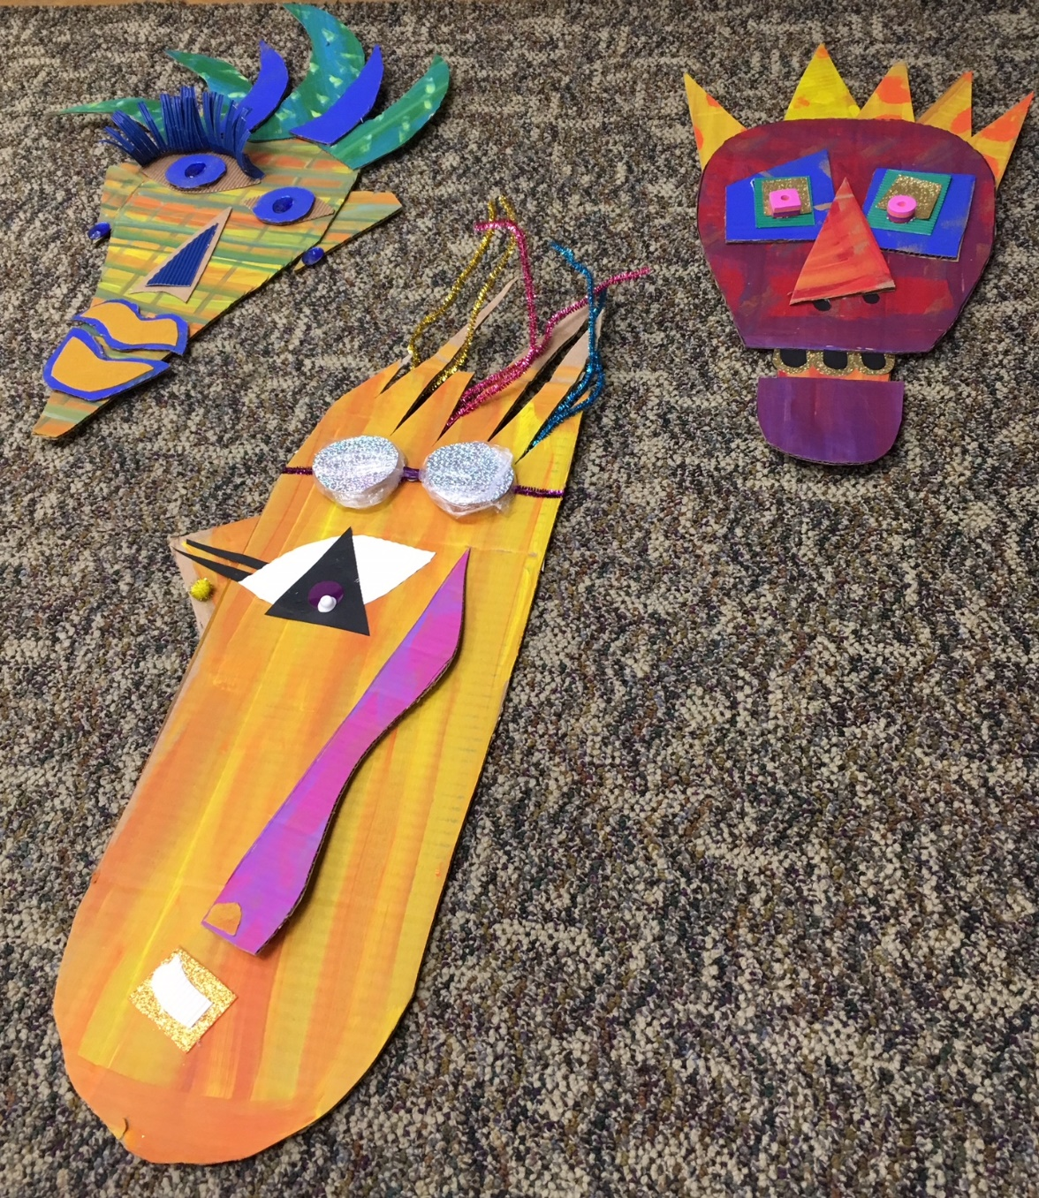

Dikenga Tactile Mask Art Experience
Developed By: Marquetta Johnson
Teaching Artist - High Museum of Art
Winter 2018

Established Goals:
- Visual Arts Standards:
VAHSVAPR.4 Understands and applies media, techniques, and processes in three-dimensional art. b. Communicates meaning in 3-D media d. Understands and practices safe handling of art media and tools..

Essential Questions:
- How can artists use line, shape and color to express mood in a work of art?
- What roles do masks play in African Societies?

Objectives:
Students will understand:
- The general function of the Masks in special ceremonies and in the daily life of African communities
- That art can be made with almost everything

Students will be able to:
- Express feelings in a work of art with line, shape and color.
- Use designs that reflect their point of view, culture and family life.

Students will appreciate:
- The beauty and craftsmanship of African Masks
- The versatility of Cardboard in 3-d constructions

Performance Tasks:

- Students will create cardboard mask forms using at least 3 pre-painted geometric shapes

Key Criteria:
- Students create a 3 dimensional mask using at least 3 pieces of cardboard.
- Students use collage materials to create tactile elements in their mask with collage materials

Mini-Glossary:
Collage- a piece of art made by sticking various different materials onto a backing
Mask a covering for the face
Mood- a particular feeling or state of mind
Elements of Art- Line, Shape, Color, Texture and Form
Overlapping-to extend over or cover a part of a thing
Up-Cycling- using Recycled, re-used and re-purposed Material to create something beautiful

Permanent Collection Connections:
African Masks in the Permanent Collection

Materials:
- Precut and painted Cardboard Shapes
- Various Collage Materials
- Small bottles of Tacky Glue
- Scissors
- Hot Glue Gun and Hot Glue Sticks (Teachers Only)

Advanced Prep:
- Paint cardboard and cut into geometric shapes
- Cut collage material into useable pieces
- Prepare Visual Schedule for Design Wall and print out
8 ½” x 11 size for table topper
- Create 5 Masks for table samples

Lead-in:
African People use masks in many ways in their communities. We are look at them hanging on the walls here at the museum. However, when they are used in ceremonies and rituals, they are worn or carried. The mask is worn with power shirts, raffia collars as additional costuming. Let’s be inspired by the various African Masks here in the African Art Collection to create our own masks using Cardboard and Collage Materials.

Procedure:
- Students choose 3 or more pieces of painted cardboard for the main structure of the Mask.
- For brevity, student will arrange the pieces for the main structure of their mask form. The Teaching Artist and the Teachers will assist the students in hot gluing the main structure of the mask. Remember-add student name.
- Students visit supply table and choose materials to embellish their mask
- Using Tacky glue, tape, wire and pipe cleaners students add their chosen decorative aspects to their mask.
- Students develop a hanging mechanism for the back of their masks
- Finally, all the masks are hung on the design wall for a Mini Art Exhibit and Critique.
Critique Question Format:
Share one thing you like about the mask or
Share one thing that you think the artist did that inspired an idea for you.

Modifications:
Give Assistance for students by offering choices, if non-verbal and use the least intervention, if any is required.

Use Large Print on Table Toppers

Have Fidgets, Noise-Cancelling Headphones and Textured Cushions available, upon Teacher’s Request.

