FRIENDS & STARS, INC.
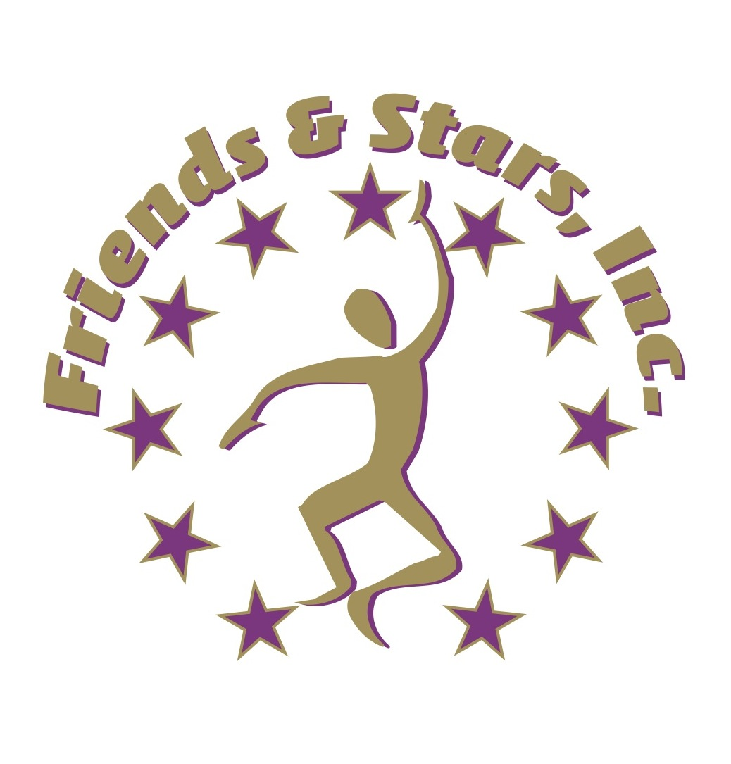
A Caring Community Supporting the Arts for Individuals with Different Abilities

LESSON PLANS

WORKSHOP for Family Central Provider Staff

ACTIVITY: Learning Styles and Standards / Integrating Visual Arts

ROOM ARRANGEMENT: Tables/chairs in U-shape formation.

EDUCATIONAL GOALS: To define arts-integration, describe the principals of arts-based learning and demonstrate a model lesson using visual arts.

LEARNING OUTCOMES (AKA Learning Objectives): The participant will:
1. Identify different learning styles (Howard Gardner’s Eight Intelligences) and cognitive domains applied to facilitating youth and senior learning activities.
2. Apply Florida’s Sunshine State Standards and Bloom’s Taxonomy in arts for learning formats.
3. Observe and discuss the essential elements of designing an arts-based learning program curriculum.
4. Explain and give examples of teaching strategies and learning outcomes in terms of knowledge, attitude, behaviors.
5. Participate in a hands-on model lesson using elements of visual arts.

METHOD: Didactic Presentation (power point), Demonstration, Printed Training Materials, Discussion, Simulation, Hands-on Arts Activity and Assignments, question/answer

1. Conduct a creative warm up activity focused as a simulation for use with clientele.
2. Learning Theory And Practice: distribute training materials and introduce Gardner’s theory of multiple intelligences, Bloom’s taxonomy, and state standards of education
3. Introduce Components of a Curriculum Overview: discuss elements of theme/curriculum development as foundation for lesson planning.
4. Introduce Components of a Lesson Plan: Identify and give examples learning outcomes of the lesson plan.
5. Simulate a visual arts lesson plan, detailing each component through hands on arts activity, assess each component through question/answer process.
6. Give homework assignment: each participant drafting a thematic curriculum overview and selects two learning strategies to achieve one learning outcome:
1) academic learning, 2) cultural enrichment or 3) social skills development.

INDICATORS OF PROGRESS: Participants will have identified their styles of learning according to Gardner, correlated specific education benchmarks for an art activity, listed 2 learning outcomes/objectives (using Bloom’s taxonomy) for the art activity, and described the rationale for developing a curriculum overview and lesson plans.

ASSESSMENT METHODS: Instructor will observe and document the participants’ class performance and their understanding in identifying essentials of arts-integrated learning. A pre/post survey will be used to measure knowledge and skill gained at the conclusion of the training program.

