# 

This enchanting Chinese tale teaches the importance of being honest. The Emperor is very old and needs to find someone to take over his duties, as he has no son. The new leader must be smart and strong, kind and courageous, patient and honest, especially HONEST. How will he find just the right boy? (Based on the story of The Empty Pot).

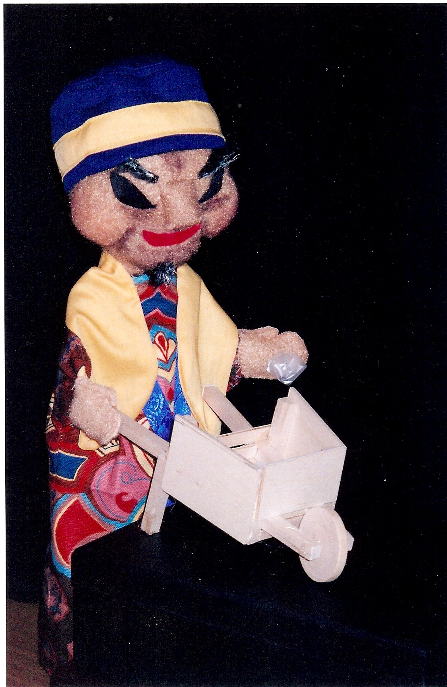

## HISTORY

## The Piccadilly Puppets have been entertaining and educating students for over four decades. Our performers are professional puppeteers who also have extensive experience working with children. We use a variety of puppetry styles and offer a large repertoire of programs that relate to curriculum.

## Awarded the UNIMA Citation for Excellence in the Art of Puppetry

* Formerly on the Artist Roster for Arts For Learning

## Duis Montes, Tellus Lobortis

In sodales libero suspendisse mauris quam etiam erat.

## Duis Montes Tellus Lobortis

Varius natoque ac turpis est leo primis elementum est.

### literacy Standard

ELACC2RL2: Recount stories, including fables and folktales from diverse cultures, and determine their central message, lesson, or moral.

Lorem Ipsum January 11, 2016

**Piccadilly Puppets Classroom Guide**

***Once Upon a Time in China***

### social studies Standard

SS2CG3: The student will give examples of how the historical figures under study demonstrate the positive citizenship trait(s) of honesty…

### Fine arts anchor Standard

8. Interpret Intent and Meaning in artistic work.

Students will be able to compare and contrast customs of China to those of the US, including how leaders were chosen in ancient China vs. the US today.

Students will be able to discuss positive traits of a good leader.

Students will be able to recognize different types of puppets used in China and in today’s performance.

Learning Objectives

What was the setting of the story?

What is an Emperor? How was the old Emperor in the story chosen for the job?

What is the Emperor’s main problem?

What are the character traits the Emperor believes are important for his job? Which one does he decide is the most important? How does he test the boys to find the right one (or, why is Ping chosen)?

Name something you saw in the show that was invented in China.

Name a type of puppet used in the show.

Asses the Learning : Questions to Ask the Students Following the Program

Pre- or post-show:

Find China on the globe and see where it is in relationship to the U.S., and compare the size of China to the size of the U.S. Find major cities and rivers.

The Chinese people no longer have an Emperor. Research to find out what kind of government they do have.

Post-show:

The Emperor says that the boy chosen to be the next Emperor must be smart and strong, kind and courageous, patient and honest. He thought of a way to test the boys for honesty. Can you think of a way he could have tested them for one of the other characteristics listed?

Research to see what other things besides the kite and wheelbarrow were invented in China, and draw pictures of those things (a few are fireworks, umbrella, paper, gunpowder, compass, chopsticks, ice cream).

Use this Venn Diagram to compare our culture to that of ancient China:

<http://www.scholastic.com/teachers/sites/default/files/asset/file/jancultures.pdf>

Extend the Learning: Post-Show Activities

* Setting
* Honest
* Emperor
* Wheelbarrow
* Soil
* Fertilizer
* Predator

Vocabulary

Websites:

[www.atozkidsstuff.com/china.html](http://www.atozkidsstuff.com/china.html) Map, brief history, activities

<http://www.activityvillage.co.uk/china> Games, crafts, printables

<http://www.scholastic.com/teachers/unit/chinese-new-year-everything-you-need> Lesson plans and activities around the Chinese New Year, but many can be used any time

[http://www.china-family-adventure.com/wildlife-in-china.html#.VOZKVcbf404](http://www.china-family-adventure.com/wildlife-in-china.html%23.VOZKVcbf404) A page showing various Chinese animals

[http://www.zooatlanta.org/1212/panda_cam#m-PPN](http://www.zooatlanta.org/1212/panda_cam%23m-PPN) Zoo Atlanta’s Panda Cam, blog and other info

Books:

Ms. Frizzle’s Adventure’s: Imperial China (Magic Schoolbus series) by Joanna Cole

Yeh-Shen : a Cinderella story from China / retold by Ai-Ling Louie ; illustrated by Ed Young.

Additional Resources