# 

Developed for the opening of the Callaway Gardens Butterfly Center, this production traces the metamorphosis of Katy and Kevin Caterpillar from egg to caterpillar, chrysalis, and butterfly. Join them on their fascinating migration to Mexico and marvel as they return to the United States to lay their eggs, beginning the life cycle all over again. The story, narrated by Mother Nature and performed with hand and rod puppets, culminates in a discussion of what each individual can do to maintain the balance of nature. Students learn a few words of Spanish; a bilingual version is also available.

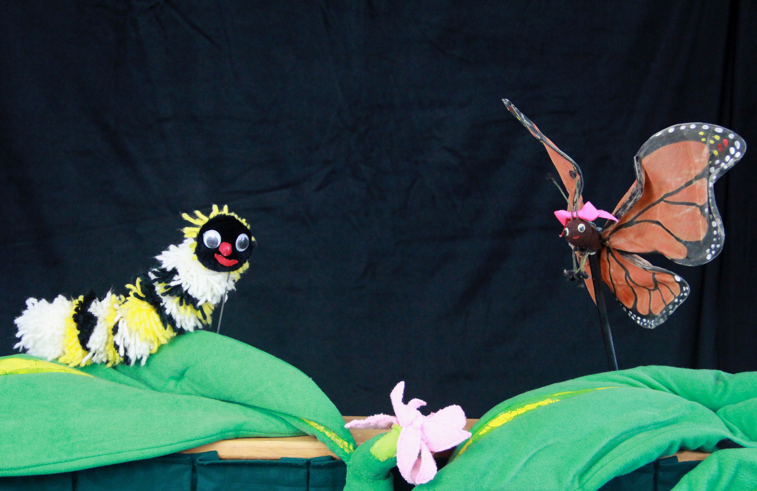

## HISTORY

## The Piccadilly Puppets have been entertaining and educating students for over four decades. Our performers are professional puppeteers who also have extensive experience working with children. We use a variety of puppetry styles and offer a large repertoire of programs that relate to curriculum.

## Awarded the UNIMA Citation for Excellence in the Art of Puppetry

* Formerly on the Artist Roster for Arts For Learning

## Duis Montes, Tellus Lobortis

In sodales libero suspendisse mauris quam etiam erat.

## Duis Montes Tellus Lobortis

Varius natoque ac turpis est leo primis elementum est.

### Science Standard

S2.L1. Students will investigate the life cycles of different organisms.

Lorem Ipsum January 11, 2016

**Piccadilly Puppets Classroom Guide**

***Butterfly Ballad***

### science Standard

S1.L1. Students will investigate the characteristics and basic needs of plants and animals.

### Fine arts anchor Standard

8. Interpret Intent and Meaning in artistic work.

Students will be able to draw the stages of Katy or Kevin’s life in order to explain the four stages of the butterfly life cycle.

Students will be able to identify the food source for the caterpillars, name some of their predators (“enemies”) and identify at least one defense mechanism the caterpillars employ.

Students will generate ideas for actions they can take to protect the basic needs of plants and animals.

Learning Objectives

Vocabulary

How were the caterpillars born? (Hatched from eggs)

What do they eat?

What were the three predators in the story?

Can you think of other animals that migrate?

What are more ways that we can “help Mother Nature” at home or at school? (Carry these out if possible by recycling paper, organizing a campus cleanup, or whatever they suggest).

Assess the Learning : Questions to Ask the Students Following the Program

Have the students draw the stages of a butterfly’s life.

Have the students demonstrate the movement of a caterpillar, butterfly, frog, spider and bird.

Trace the migratory path of the Monarch butterflies on the map.

Write a poem about a Monarch butterfly, a caterpillar, or your favorite season of the year.

Plant milkweed at your school. First, visit this site:

<http://www.eealliance.org/assets/Documents/MAG/notallmilkweediscreatedequal.pdf>

Here’s a link to places to buy milkweed:

<http://www.eealliance.org/resources---where-to-buy-milkweed>

Extend the Learning: Post-Show Activities

Environmental Education Alliance/Monarchs Across Georgia Find information on milkweed, lesson plans on Monarch butterflies for various grade levels, etc. <http://www.eealliance.org/mag>

Monarch Watch Lots of information on Monarchs <http://monarchwatch.org>

Books: Lavies, Bianco Monarch Butterflies: Mysterious Travelers (ages 9-12)

Frost, Helen Monarch and Milkweed (ages 3-8)

DK Eyewitness Books Butterfly and Moth

Field Trips: Callaway Gardens Butterfly House

The Chattahoochee and Dunwoody Nature Centers have butterfly releases (usually in the summer). Contact the nature center nearest you to see if they have any related programming.

Additional Resources

* Nature
* Molt
* Metamorphosis
* Predator
* Chrysalis
* Migration
* Predator