Performance Final – 2D – Debi West

Summative Assessment Book Making Final Project
Written and Presented by: Debi West, Ed.S, NBCT

Objective:
This assignment acts as the final lesson for the semester so students will have 3 weeks to work on these. Students will make an 8 page summative assessment accordion style book that makes a personal statement about who they are, utilizing the lessons they learned throughout the semester.
Materials:
8 pieces of 4” x 6” paper (colors are individually selected), mixed media based on the lessons they select to use, 24” x 6” drawing paper, folded into 4” back and forth to create the skeleton of the book, 2 - 5” x 7” mat boards, to act as the front and back cover of the books.

Procedures:
Students will create an 8 page (4 pages, front and back) accordion style book making a personal statement in collage/draw/paint/mixed media about who they are OR a theme-based book. The title, table of contents and back of the book will be artistically rendered as well, as part of the objectives.

Students will have several weeks to work on the insert pages of their books, looking at the 13-15 lessons they have completed over the semester, and selecting 8 of them to include in their books:
LESSONS: Name Design; Word Wall – Visualizing Vocabulary; Contour Line Studies (2 lessons); Value Scales; Grid Art; Color Study – Creative Color Wheels; Art History Learning Stools; Midterm Triptych; Pattern Designs; Painting Practice – Fruit Studies; Watercolor Still Life Work; and don’t forget to utilize the 16 sketchbook assignments, you may use 2 of these, perspective work and one other.
Students will select an overarching THEME for their book, which can be a “who am I” theme! This is important as it will either make or break the inspiration to keep moving. Students will then work on each of the 8 assignments (that will go with the theme) over the next few weeks on separate pieces of paper, and as they complete them, they will then adhere them to the book skeleton insert.
The inside of the cover will be reserved for the Title Page and/or Table of Contents, which will include the titles of the 8 pieces, along with a description of each lesson. Remind students to Be Creative with this! This will act as a sort of check list for them. The inside cover of their back page will be their written performance final based on Feldman’s Art Critique – describe, analyze, interpret and judge their favorite piece in the book and creativity adhere it to the book– 4 paragraphs!
These books will be presented to the class during performance finals. Students will reflect on these assignments, asking themselves, “what did I learn, what did I enjoy, what could I work on harder”, etc… Again, this book is part of their FINAL exam grade so remind them to NOT sit around and waste their time, work hard and work smart on this and I guarantee they will be excited with the final result!

Assessment:
I use a separate project evaluation form for this lesson. This allows my students to appropriately reflect on the learning at hand and leaves room for them to comment on the process and how they feel the final piece turned out. It also allows me to comment and give them a grade based on their learning AND their final work. This project will be graded on their presentations as well.

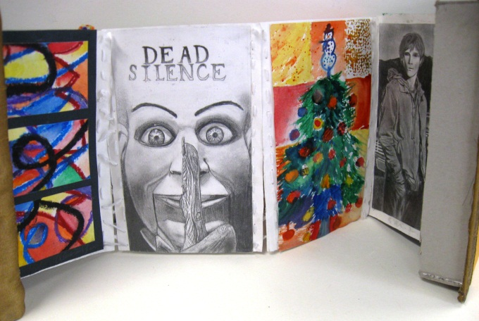
Student Samples:

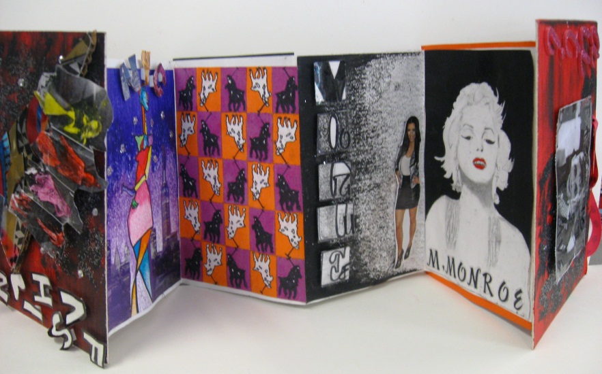
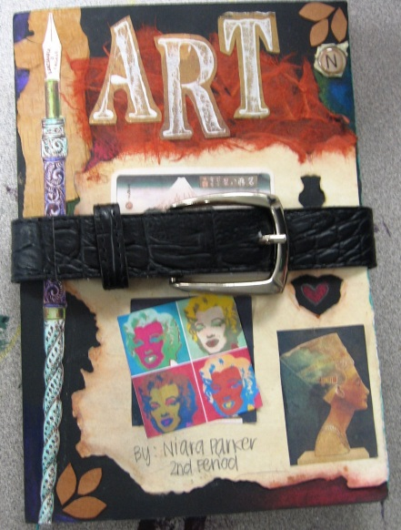

Final Project Evaluation - “Bookmaking Assignment”
Name: ______________________________ Period: ____________

Cover: 10 points _______
Table of Contents Page: 5 points _______
8 Projects: 5 points each (40) _______
Back Cover: 5 points _______

Overall Creativity: 10 points _______
Overall Craftsmanship: 10 points _______
Essay Critique: 20 points _______

Total Grade: 100 ________

Student Comments: ______________________________________________________________________________________________________________________________________________________________________________________________________________________________________________________________________________________________________

Teacher Comments:
______________________________________________________________________________________________________________________________________________________________________________________________________________________________________________________________________________________________________
Presentation Grade: __________ Final Grade: ___________

©dewestudio2013

