Book Making Assessment Project
(video link of GCPS Teacher Connection: http://cdnapi.kaltura.com/index.php/extwidget/openGraph/wid/1_ihe2hd2f)

Objective:
This assignment acts as the final lesson for the semester, so students will have 3 weeks to work on these. Students will make an 8-page summative assessment accordion style book that makes a personal statement about who they are, utilizing the lessons they learned throughout the semester. This is a traditional art education assessment tool but can be used for all disciplines as wonderful teaching tools.
Materials:
8 pieces of 4” x 6” paper (colors are individually selected), mixed media based on the lessons they select to use, 24” x 6” drawing paper, folded into 4” back and forth to create the skeleton of the book, 2 5” x 7” mat boards, to act as the front and back cover of the books.

Procedures:
Students will create an 8-page (4 pages, front and back) accordion style book making a personal statement in collage/draw/paint/mixed media about who you are or a theme on the front and the back of the book.

Students will have several weeks to work on the insert pages of their books, looking at the 13 lessons they have completed this year, and selecting 8 of them to include in their books:
Name Design; Word Wall – Visualizing Vocabulary; Contour Line Studies (2 lessons); Value Scales - Grid Art; Color Study – Creative Color Wheels; Shoe Study Triptych (3 lessons); Art History Learning Stools; Pattern Designs; Kandinsky Inspired Musical Art; Painting Practice – Fruit Studies; Watercolor Still Life Work; and don’t forget to utilize your 16 sketchbook assignments, you may use 2 of these, perspective work and one other
Students will select an overarching THEME for their book! This is important as it will either make or break the inspiration to keep moving. Students will then work on each of the 8 assignments (that will go with the theme) over the next few weeks on separate pieces of paper, and as they complete them, they will then adhere them to your book skeleton insert.
The inside of cover will be reserved for the Title Page and/or Table of Contents, which will include the titles of the 8 pieces, along with a description of each lesson. Remind students to Be Creative with this! This will act as a sort of check list for them. The inside cover of their back page will be their written performance final based on Feldman’s Art Critique – describe, analyze, interpret and judge their favorite piece and creativity adhere it to the book– 4 paragraphs!
These books will be presented to the class during performance finals. Students will reflect on these assignments, asking themselves, what did you learn, what did you enjoy, what could you work on harder, etc… Again, this book is part of their FINAL exam grade so remind them to NOT sit around and waste their time, work hard and work smart on this and I guarantee they be excited with the final result!
Enjoy and study for your final exam! Don’t forget about the elements of art (LSVCTSF) and the principles of design (MRBVCUREPP). These will be on your final exam for sure!
Assessment:
I use a separate project evaluation form for this lesson. This allows my students to appropriately reflect on the learning at hand and leaves room for them to comment on the process and how they feel the final piece turned out. It also allows me to comment and give them a grade based on their learning AND their final work. This project will be graded on their presentations as well.

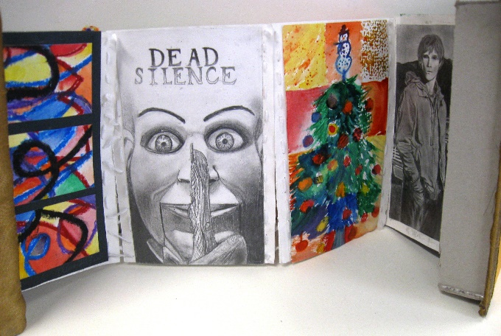
Student Samples:

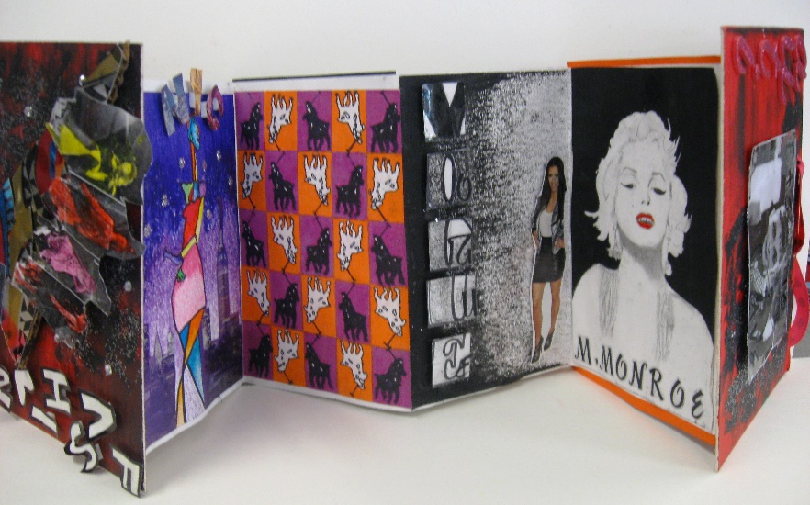

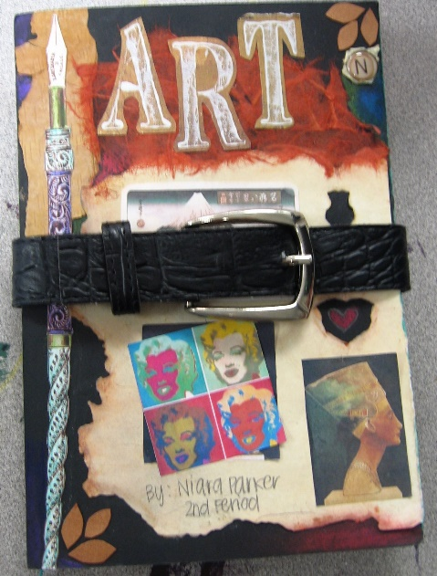

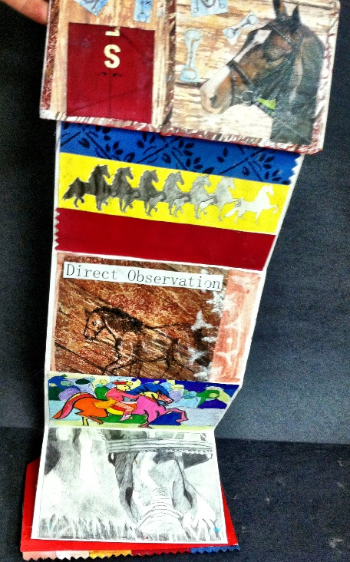
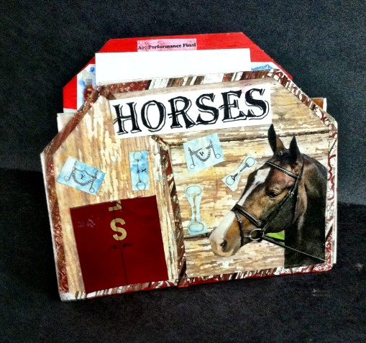

dewestudio©

