A Company of Friends Educational Productions
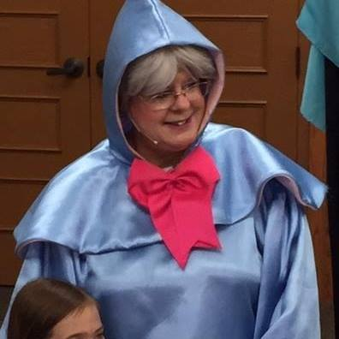
*Bringing interactive, educational, musical and high quality theatrical experiences to schools, libraries, camps, day care centers and children’s events since 1999
*Former members of Arts for Learning / Atlanta Young Audiences
*Show run 45 – 50 minutes and is accompanied by full sound support, ornate costumes, creative sets, professional actors and educational study guides.
*Shows are very flexible and play well in large rooms, cafeterias, libraries or any large open area.
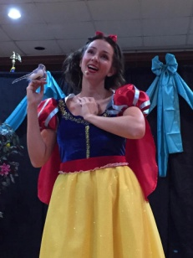
A Fairyland Fable By Gayann Truelove and Tammy Jane Barton
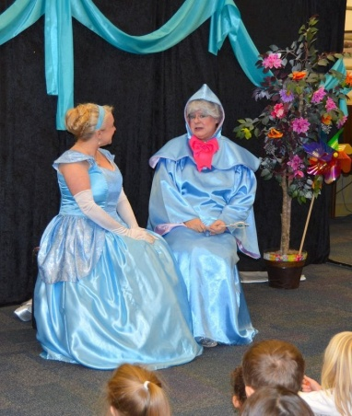
(A musical tale about what it means to have and be a true friend! Featuring The Fairy Godmother, Cinderella, Snow White and The Ice Queen)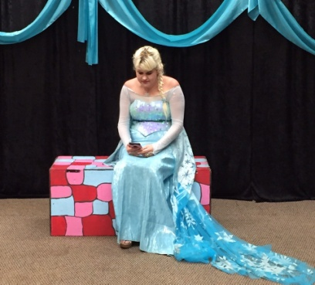

About The Show
There’s trouble in Fairytale Land. The Fairy Godmother must find out who is stealing Cinderella’s and Snow White’s most precious possessions. With a little bit of magic, plenty of laughs, clever audience interactions and a lot of adventure, we find the thief is none other than the Ice Queen herself. But, the reasons for her crimes go much deeper than just the tip of the iceberg! Lessons of honesty, friendship and trust are taught, as well as finding out that jealously and loneliness can certainly cause anyone to have a bad attitude, which can be changed through love, acceptance and understanding! Beautiful songs, ornate costumes and a cast that will delight! (Grades Pre-K through 5th grade will be enchanted by this show.)
Performances Prices One Performance: $525 Two Performances: $655 Three Performances: $785 (NOTE: A 60 cent per mile gas cost will be added to fees for locations more than 40 miles from Peachtree City, Ga. Locations farther than 60 miles from Peachtree City require a hotel stay.)

