A Company of Friends Theatrical Productions Professional Troupe

A Fairyland Fable

Study Guide 2015 / 2016

Our show features four professional actors, full sound support and is best viewed by young audiences of 250 or less. This 45-minute show is a magical, musical, elegantly costumed and cleverly set gem that offers numerous opportunities for audience interaction and learning. Four upbeat and beautiful songs add sparkle to this musical as audiences meet the loving and magical Fairy Godmother, the elegant and always cheerful Cinderella, who loves her glass slippers, and the soft spoken gentle hearted Snow White, who adores her birds. The story also features the beautiful Ice Queen who is misunderstood and holds some small secrets. The story begins with the Fairy Godmother welcoming everyone to the magical and mysterious Fairyland . Join us at the Old time Country Fair full of laughter, music and mayhem. Mystery and heartfelt sentiment abound in this engaging story that teaches audiences that friendship is one of the greatest forms of magic in the world!

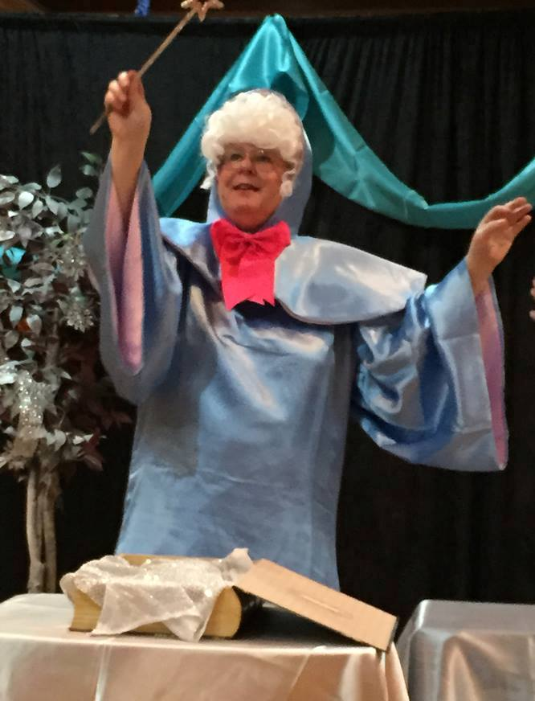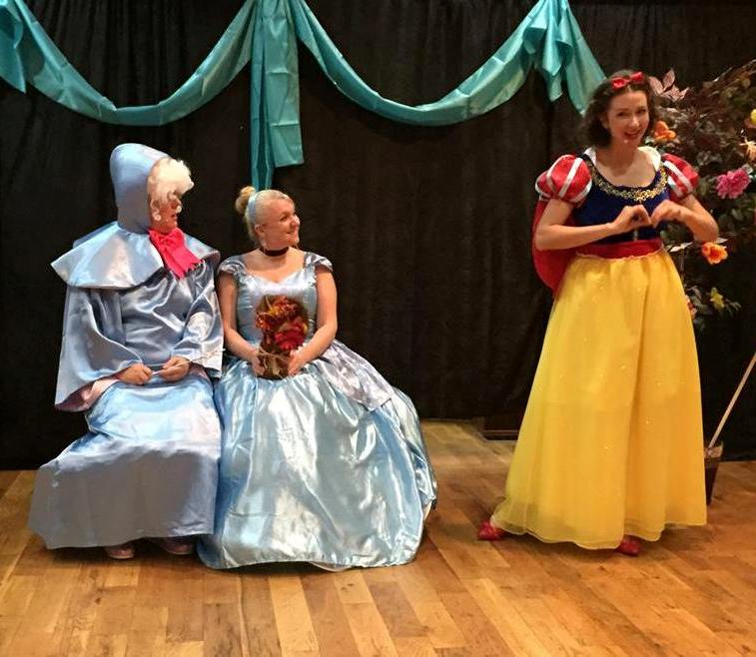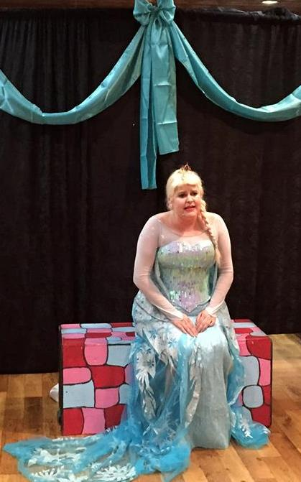

1
ACOF Bio

A Company of Friends Theatrical Productions has been touring Georgia libraries, schools and children's events since 1999 bringing high quality, interactive, musical and learning experiences to thousands of children annually. All members of ACOF are professional actors who are highly aware that theatre is a powerful tool for learning. Many ACOF performers are teachers or former teachers who have created theatre based curriculum at their schools for special needs and mainstream students. All ACOF members believe that live, interactive theatre helps build self-esteem, awareness and understanding of our unique and wonderful differences and teaches as it entertains and enriches the lives of all students.

Key Vocabulary Words

- Mystery Kindness neglected
- Loyal intrigued troubled
- Tasks friendship Play Musical
- Theater etiquette Director Cast

Objectives

The student will be able to Determine or clarify the meaning of unknown words that were introduced today in the theatrical performance.

The student will be able to use words and phrases acquired through a variety of dramatic forms such as narrated story, or a theatrical production.

The student will identify which vocabulary words have multiple meanings.

2
Standards

TAES1.1 Analyzing and constructing meaning from theatrical experiences, dramatic literature, and electronic mediate
a. Uses basic theater vocabulary to discuss theater experiences
b. Discusses how dramatic elements such as character, setting, plot, problem, and
resolution in theater experiences are like, and unlike, real life
c. Identifies big ideas and themes in a story or theater experience
d. Infers character thoughts and feelings through their actions and words

ELACCKRL2 Key Ideas and Details:
~With prompting and support, retell familiar stories, including
key details.
~ELACC1RL2 Key Ideas and Details: Retell stories, including key
details, and demonstrate understanding of their central
message or lesson.

Access The Learning
Include a list of questions that can be asked to assess student learning following the program.

1. Describe the characters in the story. Who is your favorite and least favorite and why?

2. How does the characters actions contribute to the events in the story?

3. Identify the main idea of the story using key details?

4. What does it mean to be a true friend? Describe your best friend? What makes your friendship so special? What have you done to be a true friend?

3
Extend The Learning

Include at least 3 suggestions of activities that can extend the learning. These can be pre-show activities and/ or post-show activities.

1. The teacher can introduce simple theater vocabulary before the day of the performance. Theater vocabulary will be provided with the study guide.

2. The teacher can also discuss how to participate as audience
and Identify the basic elements of theater etiquette. Theater etiquette examples will be provided with the study guide.

3. The teacher can work with the students to develop a class play and create scripts for their class play. The play could be presented to the parents at Open House or another designated school activity.
4. The students can use dramatic elements such as character, setting, problem, plot, resolution,
beginning-middle-end in developing the play.
5. The teacher could introduce improvisational activities after watching the play presented today and reintroduce these activities when reading different texts throughout the year. This could also be used as a performance assessment.

6. The students can draw an illustration of the Old Time Country Fair and write a sentence describing their illustrations. The student may write multiple sentences depending on the student’s ability.

7. The teacher may use Reading Theater during center time or guided reading or reading time. We have included various websites to use as additional resources for any teachers who have already implemented this in their classroom or for those that are interested in implementing this as a new way to teach many reading standards and listening and speaking standards for their grade level.

4
Additional Resources

Include relevant websites, apps, books, music, etc...
http://www.musical-theater-kids.com/kids-theater-dictionary.html
http://www.improv4kids.com/ImprovGames.html
http://www.childdrama.com/lessons.html
http://www.teachingheart.net/readerstheater.htm
http://www.childdrama.com/mainframe.html

Reader's Theater
Reader's Theater has become really popular in the last couple years as a way to practice and perfect student's fluency and speaking skills. There are many different ways to use RT in the classroom. Some teachers using it in small groups during guided reading as a center activity. Students practice throughout the period and then perform it for the whole class at the end of reading time or recording themselves on tape. Below I will share how I learned to do RT.

Where Can I Find Scripts?
Here are some websites with FREE scripts:

http://www.readinglady.com/index.php?name=Downloads&req=viewdownload&cid=7
Pages and pages of readers theaters to down load

http://www.aaronshepard.com/
Other great ones with tips on using RT.

http://www.teachingheart.net/readerstheater.htm
Lots of different resources for all ages.

http://loiswalker.com/catalog/guidesamples.html

http://richmond.k12.va.us/readamillion/readerstheater.htm

http://www.surfcitydelux.com/readerstheater/index.html
Excellent!!!!!

http://www.cdli.ca/CITE/langrt.htm

http://www.educationworld.com/a_curr/reading/index.shtml#theater
A few holiday and fractured fairy tales.

http://pbskids.org/zoom/activities/playhouse/
Readers Theaters from PBS.

http://www.myteacherpages.com/webpages/JGriffin/readers.cfm
several short readers theater

books

Pretend Play As Improvisation: Conversation in the Preschool Classroom, by Sawyer

Theatre Arts in the Elementary Classroom: Kindergarten Through Grade Three Hardcover – March, 1996
By Barbara Wills
Fairy Tales Reading Theatre by Creative Teaching Press.
5
Theater Vocabulary

Cast - the people who perform in a show
Choreographer - the person who creates dances and arranges movements for a musical
Costumer - the person in charge of the costumes for a show
Crew - all the people who work together on a show except the cast
Director - the person who provides the vision of how a show should be presented, who works with the actors on their roles, develops the blocking, and is in charge of the rehearsals
Lighting Designer - the person who designs the lighting for a show and works with the director to get desired effects
Musical Director - the person who works with the director, actors and orchestra to get the desired musical effects for a show
Stage Manager - the person who runs the show from opening curtain to closing curtain and is in charge of everything on the stage and in the back of the stage
Troupe - a group of actors that form a company
Backstage - the part of a theater which is not seen by the audience, including the dressing rooms, and wings
Broadway - the largest and most famous theatrical district in New York City
Stage Left - (these left/right directions are seen from the ACTORS point of view on the stage) this is when the actor standing in the center of the stage moves to his left( This even stumps some pros so it is best to learn it now)
Stage Right - (these left/right directions are seen from the ACTORS point of view on the stage) this is when the actor standing in the center of the stage moves to his right (This even stumps some pros so it is best to learn it now)
Upstage -1) the area of the stage that is the farthest away from the audience
Wings - the areas of the stage that are to the sides of the acting area and are out of view. These areas are usually masked by curtains.
6
Set - the setting of the stage for each act and all the physical things that are used to change the stage for the performance
Act - 1)the main sections of a musical or play 2)the thing which actors can do
Audition - a time when an actor goes before a group of people who are casting a play to show those people what he can do
Callback - when an actor who has auditioned for a show is asked to come back for a second tryout
Blocking - the instructions that actors use to know exactly where they are supposed to be on stage at all times
Curtain - the screen usually of cloth which separates the stage from the audience
Curtain call - the bows at the end of a performance
Dress Rehearsal - a rehearsal, usually just before a show opens, to practice the show just how it will be on opening night, including costumes and make-up. A rehearsal for both cast and crew
Personal Props - props that are carried by an actor in his costume during a performance
Sound Effects - the noises which are produced to accompany a scene in a show...these noises are mostly produced by a machine but can be produced by actors off stage
Monologue - a speech given by one actor
Break A Leg -something people tell actors to wish them "Good Luck" before a performance or audition.

7

Theater Etiquette
*Arrive to the theater on time.
*Visit the restroom before the performance begins.
*Pay attention to announcements that are made prior to many shows about the rules of the theater you are attending and the location of the fire exits.
*Don't speak during the performance...whispering is still speaking, so only in an emergency.
*Remember that the Overture (introductory music) in Musical Theater is part of the performance, so be quiet when it begins.
*Remain in your seat for the entire performance. If you must leave, exit during intermission. In an emergency, wait for an appropriate break in the show. It is rude to get up in the middle of a quiet moment...rude to the actors and your fellow audience members.
*Don't put or throw anything on the stage.
*Do laugh when the performance is funny.
*Do applaud when it is appropriate during the performance.
*Do applaud when the performance is over...this tells the performers and crew that you appreciate their work.
*Stand and applaud if you really thought the show was great.

8

